flag

|  |  |
| --- | --- |
| **Last Updated:** | October 11, 2019 |

|  |
| --- |
| **ChemBioOffice Enterprise 19.1** |
| **Installation Guide** |

 **Table of Contents**

1. Introduction 4

2. System Components 4

3. System Requirements 4

4. Database Server Installation 4

4.1. Overview 4

4.2. Oracle Server Configuration 5

4.3. Oracle Cartridge Installation 7

5. Application Server System Configuration 9

5.1. Oracle Client Configuration 9

5.2. Internet Information Server Configuration 10

5.3. Enabling Secure Sockets Layer (SSL) and Installing SSL Certificate 12

6. Application Server Installation 20

6.1. Overview 20

6.2. Before Proceeding to Install 21

6.3. Configuration Verification for Windows Server 21

6.4. Configuration Verification for IIS 26

6.5. Installing ChemBioOffice Enterprise 19.1 27

6.6. Installing ChemACX 34

6.7. Activate ChemDraw Professional 34

6.8. Activate ChemScript 35

7. Database Schema Creation 37

7.1. Overview 37

7.2. Database Schema Creation 38

7.3. Verification of Database Parameters 43

8. Application Server Configuration 44

8.1. Overview 44

8.2. Configuration Files 44

8.3. Configuration Tool 45

8.4. Additional Configuration 53

8.5. Configuration Changes for Web Registration (Optional) 55

9. Importing Application Configuration 56

9.1. Importing Chemical Registration Configuration 56

9.2. Updating invconfig.ini file for non C-Drive Installation 58

9.3. Configuration Settings for Inventory Reporting 59

10. Client Workstation Installation 67

10.1. Installing ChemDraw ActiveX (CDAX) Enterprise Constant NA 18.1 67

10.2. InvLoader Installation 71

11. Upgrading CBOE 12.1.3, 12.6.3 PF1, CBOE 17.1 CBOE 17.1.1, CBOE 18.1, and CBOE 18.1.1 to CBOE 19.1 74

11.1. Uninstalling the Old Version of CBOE (Only for CBOE 12.1.3/12.6.3 PF1 to CBOE 19.1 Upgrade) 75

11.2. Upgrading ChemBioOffice Enterprise Server 76

11.3. Activate ChemDraw and ChemScript 76

11.4. Upgrading CBOE Database Schemas 76

11.5. Running the Server Configuration Tool 81

11.6. Upgrading Client 81

12. Troubleshooting 82

12.1. ‘Could not load file or assembly Oracle.DataAccess’ Error 82

12.2. Registering ASP.Net in IIS 82

12.3. .Net Framework Security 82

12.4. Oracle 11g or 12c Related Issues 83

12.5. Error in RLS Log File 'log_runRLSConfigurationTool.txt 84

12.6. Inventory Reporting Errors 84

12.7. Invalid Character Error in Japanese Environment while Importing Configuration 84

12.8. Error: ChemDraw Control Version is Not Supported in Server Side 85

12.9. Inventory Application Stops Working After Configuring Inventory Reporting 85

12.10. Receive Orders Window in Inventory Expiries after 20 Minutes despite the Session Timeout Settings of the System 86

12.11. Degree and Period Symbols in S Sentences and P Precaution Sentence are not Displaying Properly 88

12.12. Unable to Browse Inventory Content after Changed Authentication from ORACLE to LDAP or vice versa Once the CBOE System is Setup 89

12.13. Unknown Error Displays when Trying to Search for a Query While Adding a New Component to a Mixture 90

12.14. Errors While Creating New User and Submitting Record to Registration Temp Table in an Oracle 12c Upgraded Machine 91

12.15. Invalid Objects in CBOE 19.1 Fresh Database 91

12.16. Unable to Launch E-Notebook from CBOE Manager after Upgrading CBOE 92

12.17. Loading Compounds from MS Excel 2016 Files Using Inventory Loader and Data Loader is Showing Error 92

12.18. Exporting Shopping Cart Details to MS Excel Fails in ChemACX 93

12.19. Plate Creation from Excel File Fails on an MS Office 2016 Installed Server 96

12.20. Searching of Large Records in Registration Takes More Time in Internet Explorer 97

1. Introduction

This guide provides instructions for installing and configuring ChemBioOffice Enterprise 19.1. ChemBioOffice Enterprise 19.1 installer is also designed for upgrading your old version of ChemBioOffice Enterprise (CBOE 12.1.3, CBOE 12.6.3 PF1, CBOE 17.1, CBOE 17.1.1, CBOE 18.1, and CBOE 18.1.1) to the most recent one, ChemBioOffice Enterprise 19.1. It also provides integration support with the latest version of our flagship E-Notebook 19.1.

1. System Components

The ChemBioOffice Enterprise 19.1 distribution includes the following application modules:

* COE Framework 19.1
* Registration Enterprise 19.1
* Web Registration 19.1
* Inventory Manager Enterprise 19.1
* ChemACX Enterprise 19.1
* DataLoader 19.1
* InvLoader 19.1

The distribution package includes the following components:

* Oracle Cartridge 15.1
* Oracle Cartridge 15.1.2

In addition, the following components are also distributed with the ChemBioOffice Enterprise 19.1 suite because they are required for the proper functioning of the above modules:

* ChemOffice Professional 18.1
* ChemScript 18.1
* ChemDraw ActiveX Enterprise Constant Non-Admin 18.1.1.10c
* CDJS 18.1

1. System Requirements

ChemBioOffice Enterprise 19.1 is deployed in 3 tiers using physical or virtual servers. Specific requirements for Database Server, Application Server, and Client Workstation are mentioned in the “*CBOE19.1 Hardware Software Guide*” document.

1. Database Server Installation

## Overview

The only PerkinElmer component required on the database server tier is the Oracle Cartridge. The Oracle Cartridge implements an Oracle Domain Index that enables applications to perform chemical queries in the Oracle database server. The Oracle Cartridge is therefore required by many PerkinElmer as well as third party applications. Detailed instructions for Cartridge Installation are provided in the “*Oracle Cartridge User’s Guide”* document. This section provides a brief description of the Cartridge installation process suitable for the most common scenarios encountered during a ChemBioOffice Suite installation.

Installation of the Oracle Cartridge on a host Oracle server consists of the following main steps:

1. The configuration of the Oracle host to support Domain Indexes.
2. Installation of the Oracle Cartridge program on the host server.
3. Creation of a Cartridge Oracle schema.

***Note****: Before installation, make sure that the Install User (usually System user) can connect to Oracle as SYSDBA:  
Connect &&InstallUser/&&sysPass@&&serverName as SYSDBA;  
If this command returns an error, need to ask the customer DBA to run as SYS (as sysdba):  
grant SYSDBA to system;*

## Oracle Server Configuration

Cartridge is a program written by PerkinElmer which cooperates with the Oracle server to provide chemical searching capabilities. Oracle interacts with such third party programs via a specialized Oracle client program referred to as the “external procedure agent” or “extproc” for short. Extproc differs from other Oracle client programs in that it gets executed in the Oracle server rather than on a remote client machine. Extproc, like any other Oracle client program, needs to know how to connect to the Oracle server. The extproc connection process is affected by the configuration found in three Oracle files: listener.ora, tnsmanes.ora, and sqlnet.ora. These files are typically located on the server under:

ORACLE_HOME/network/admin

### Listener.ora

Listener.ora is the file used by the Oracle listener service to mediate connections between an Oracle client and the database server. It defines which client programs can connect to the server as well as details on the protocols used for that connection. Oracle listeners are highly configurable. For example, there may be multiple listeners associated with your database, and each listener can manage multiple types of service requests. This is a complex topic, the many variations of which are not covered in this document. Please refer to the "Oracle Database Net Services Administrator's Guide" for details about configuring your listeners. Furthermore, it is highly recommended that changes to this file be only performed under the supervision of an experienced Oracle DBA.

Below is a simple example which uses a single listener to manage connections from both remote Oracle clients and the local extproc. This file may be significantly different for every database instance.

|  |
| --- |
| SID_LIST_LISTENER =  (SID_LIST =  **(SID_DESC =**  **(SID_NAME = PLSExtProc)**  **(ORACLE_HOME = C:\app\Admin\product\11.2.0\dbhome_1)**  **(PROGRAM = extproc)**  **(ENVS="EXTPROC_DLLS=ANY")**  **)**  (SID_DESC =  (SID_NAME = ORADB)  (ORACLE_HOME = **C:\app\Admin\product\11.2.0\dbhome_1)**  (GLOBAL_NAME = ORADB)  )   LISTENER =  (DESCRIPTION_LIST =  (DESCRIPTION =  (ADDRESS = (PROTOCOL = TCP)(HOST = dgb2.camsoft.com)(PORT = 1521))  **(ADDRESS = (PROTOCOL = IPC)(KEY = EXTPROC0))**  )  ) |

The highlighted regions represent the entries required by Oracle to support the Oracle Cartridge or any other program that depends on external libraries.

Below are some explanations of the entries in this section:

* + - 1. SID_LIST_LISTENER

This label begins a list of SIDs to be handled by the listener named LISTENER (the default listener name).

* + - 1. SID_LIST and SID_DESC

The example above defines two services, which are listed as two SID_DESC entries under the heading SID_LIST. The first in the list (PLSExtProc) handles extproc requests and the second (ORADB) handles remote client connections.

* + - 1. SID_NAME = PLSExtProc

This entry corresponds to the SID specified for the extproc in the file tnsnames.ora described below.

* + - 1. ORACLE_HOME

This entry defines the location of the Oracle Home for this service. The extproc program files load from a folder beneath this location. This path will differ for each installation but must correspond to the actual Oracle home location.

* + - 1. PROGRAM

This entry specifies the file name of the extproc executable file. This case-sensitive name might be extproc, extproc.exe, or extproc32, depending on the operating system type. The file is located in ORACLE_HOME/bin.

* + - 1. ENVS

This is a list of environment variables that the extproc uses when it runs. The list is colon-delimited. This list could include a definition of the environment variable EXTPROC_DLLS (see below) and possibly other environment variables that the extproc may use at runtime. For example, it may be desirable to include LD_LIBRARY_PATH on UNIX and Linux systems. LD_LIBRARY_PATH should typically include the location of the Oracle Cartridge library.

* + - 1. EXTPROC_DLLS

This environment variable defines a list of libraries that the extproc can load and call functions from directly. The ANY keyword is used above to allow extproc to load any library within its path. The specific path to the Oracle Cartridge library file (CSCartridge.dll, CSCartridge.so or CSCartridge.sl) could be specified instead to limit the code base accessible to extproc.

The list is colon-delimited. All paths must be absolute. There is no environment variable substitution. The optional keywords ANY and ONLY can be used to loosen or restrict the way the extproc uses library files. In many cases, neither keyword is needed.

* + - 1. KEY = EXTPROC0

The name in the example, EXTPROC0, links this listener with the corresponding service entry in the file tnsnames.ora. It distinguishes this listener from other IPC listeners that might be present on the same database server. The key can be any short name but must be the same in the files listener.ora and tnsnames.ora. The key is case sensitive.

### TNSNames.ora

The file tnsnames.ora contains a directory of known database services. This file can define services on the local database or on remote servers. One entry is specifically for use by the local database server to use interprocess communications (IPC) to send function calls to the extproc.

This entry is always labeled EXTPROC_CONNECTION_DATA.

Here is an example as it appears in the file tnsnames.ora. (Please note that this will probably not be the only entry in the file).

|  |
| --- |
| EXTPROC_CONNECTION_DATA =  (DESCRIPTION =  (ADDRESS_LIST =  (ADDRESS = (PROTOCOL = IPC)(Key = EXTPROC0))  )  (CONNECT_DATA =  (SID = PLSExtProc)  (PRESENTATION = RO)  )  ) |

* + - 1. EXTPROC_CONNECTION_DATA

This entry must always have the label EXTPROC_CONNECTION_DATA.

* + - 1. Key and SID

The two items in this entry that could be changed are the name of the key (EXTPROC0) and the SID (PLSExtProc). These items are used to link this entry to corresponding information in the listener.ora file. The key can be any short name but must be the same in both the listener.ora and tnsnames.ora files. These values are case sensitive. They are only used by the listener process, not by users or applications.

### SQLNet.ora

The SQLNet.ora file is not directly used by the extproc calling infrastructure; however, it may contain entries which affect the ability of the listener to reach the services described in the TNSNames.ora file. This section covers SQLNet.ora entries that can indirectly affect extproc operation.

In order for extproc to use the TNSNames.ora services, the SQLNet.ora file must contain the following entry:

NAMES.DIRECTORY_PATH= (TNSNAMES,ONAMES,HOSTNAME)

There may be additional items inside the parenthesis, but the TNSNAMES entry is required and should be the first entry in the list.

### Library Dependencies

The above .ora file configuration settings allow the extproc program to locate and call functions in the Oracle Cartridge library. However, Oracle Cartridge itself depends on other Oracle or operating system libraries. These dependent libraries must be present on the Oracle server system and accessible to the user that executes the extproc process. The list of dependent libraries differs for each of the platforms supported by the cartridge. A detailed table can be found in CS Cartridge User’s Guide.

For Unix systems, in addition to verifying the presence and access permissions for all dependent libraries, it is also necessary to ensure that path(s) to the library locations is present in environment path variables such as LD_LIBRARY_PATH, SHLIB_PATH, or LIBPATH. Please consult the Unix manuals for information on properly setting those environment variables.

## Oracle Cartridge Installation

The installation of the Oracle Cartridge program and the creation of the Cartridge Oracle schema are most easily accomplished by using the automated Oracle Cartridge Installer utility. This is a Windows application specifically designed to simplify the deployment of the cartridge on all supported Oracle host platforms. The installer utility, however, introduces some requirements that may not be achievable in some production Oracle environments. A manual installation process described in the *CS Cartridge User’s Guide* can be used to circumvent some of the installer requirements. For all other cases, the automated installation process described below is recommended.

### Installer Requirements

The following prerequisites must be met in order to complete the installation of the CS Cartridge using the installation utility:

* Ensure that the Database Server system requirements have been met.
* Ensure that the Oracle server has been configured according to the guidelines provided in section Oracle Server Configuration above.
* The password for the Oracle SYS account must be known. The use of SYSTEM or other DBA privileged Oracle users is not sufficient.
* The target Oracle instance must have a tablespace named “USERS”. This tablespace is used as the default tablespace for schema owners created by the Cartridge installer utility during its automated testing process.
* A Windows system equipped with the Oracle client and capable of connecting to the target Oracle host must be available to run the installer utility.
* For Windows Oracle hosts, the Cartridge installer must be run on the server itself.

If any of the above requirements cannot be met, then a manual cartridge installation is recommended.

### Oracle Cartridge Installation (Fresh)

***Note****: Only ORACLE CARTRIDGE 15.1 is supported.*

***Note****: To install Cartridge from middle-tier, 64-bit Oracle Client is needed.*

| **Step** | **User Input/Action** | **Expected Results** |
| --- | --- | --- |
| 1 | Locate and run the file SetupCartridge.exe | Installation window opens |
| 2 | Enter Service Name | Service Name entered |
| 3 | Enter the Sys Password | Password entered |
| 4 | Enter the Computer name or IP address | Computer name or IP address entered |
| 5 | Enter the User name with access rights to Oracle instance (not root) | User name entered |
| 6 | Enter the Password for the above User | Password entered |
| 7 | Select the install mode ("Full" for new install, "Partial" for upgrade) | Install mode selected |
| 8 | Enter the tablespace, or leave T_CsCartridge  ($ORACLE_HOME\Database\T_CSCartridge.DBF) as default | Tablespace name entered |
| 9 | Click 'OK' | A series of command will run as indicated in the status window.  When complete, an "Installation succeeded" window will open. |
| 10 | Click 'OK' | The Oracle cartridge user's guide will open |
| 11 | Close the Oracle cartridge test system. | Window closes. |
| 12 | When done reading, close the user's guide. | Window closes. |

***Note:*** *A full description of the Cartridge features and functions is in the User’s Guide which is part of the Cartridge installer package.*

1. Application Server System Configuration

This section describes the configuration and verification of non-PerkinElmer system components that the ChemBioOffice Enterprise products require. It assumes that the hardware and software prerequisites have been met. If any of the required configuration steps cannot be performed or verified, no PerkinElmer software should be installed until a remedy has been found.

## Oracle Client Configuration

The application server uses several Oracle client components to communicate with the database server. This section describes the steps necessary to configure and verify connectivity to the server. Note that some of the files and configuration tasks are similar to those performed on the Oracle Server itself, to support the Oracle Cartridge connectivity. Make sure that the steps described below are performed on the Application Server, not on the database server. Note, however, that if the Oracle Server and Application Server are installed on a single host system, then all configurations will take place on the single server.

***Note****: On the middle-tier, ensure that the Oracle data access dll (Oracle.DataAccess.dll) and the policy dlls are registered in GAC. If the dlls are not registered in GAC, you need to register it manually.*

*Following is an example of how the dlls are registered in GAC on an Oracle 18c middle-tier.*

*Execute the following command.*

*set Oracle_x86=C:\app\client\Administrator\product\18.0.0\client_2\odp.net  
set OraProvCfg_x86=%Oracle_x86%\bin\4\OraProvCfg.exe*

*"%OraProvCfg_x86%" /action:gac /providerpath:%Oracle_x86%\bin\2.x\Oracle.DataAccess.dll*

*"%OraProvCfg_x86%" /action:gac /providerpath:%Oracle_x86%\PublisherPolicy\2.x\Policy.2.102.Oracle.DataAccess.dll*

*"%OraProvCfg_x86%" /action:gac /providerpath:%Oracle_x86%\PublisherPolicy\2.x\Policy.2.111.Oracle.DataAccess.dll*

*"%OraProvCfg_x86%" /action:gac /providerpath:%Oracle_x86%\PublisherPolicy\2.x\Policy.2.112.Oracle.DataAccess.dll*

*"%OraProvCfg_x86%" /action:gac /providerpath:%Oracle_x86%\PublisherPolicy\2.x\Policy.2.121.Oracle.DataAccess.dll*

*"%OraProvCfg_x86%" /action:gac /providerpath:%Oracle_x86%\PublisherPolicy\2.x\Policy.2.122.Oracle.DataAccess.dll*

### TNS Names Configuration

The application server must be able to resolve the address of, and connect to, the target database service. To test this connectivity:

1. Open a windows command prompt

2. Execute the command: tnsping <serviceName>

**Note**: <serviceName> must be substituted by the actual name of the target Oracle service.

The TNSPing utility will respond with connection details and success or failure messages.

3. If the connection is not successful, open the TNSNames.ora file located on the application server at: ORACLE_HOME\network\admin

The file should contain a section similar to:

<serviceName> = (DESCRIPTION =(ADDRESS_LIST = (ADDRESS = (PROTOCOL = TCP)(HOST = <host>)(PORT = 1521)) ) (CONNECT_DATA = (SERVICE_NAME = <SID>) ))

where:

<serviceName>, is a friendly name to designate the target Oracle Service.

<host>, is the name or IP address of the target Oracle Server host.

<SID>, is the unique service identifier for the target Oracle instance.

### SQLNet Configuration

Connections between the application server and the Oracle database use credentials supplied by the end user. The use of the Windows authentication is not supported for the Oracle client hosted by the application server. It is therefore recommended that the SQLNet.ora file is modified to prevent NTS authentication.

1. Edit the SQLNetOra file at *ORACLE_HOME\network\admin*

2. Ensure the following entry is present in the file:

* SQLNET.AUTHENTICATION_SERVICES= (NONE)

The standard value for this entry (if present) is typically NTS. It should be changed to NONE.

Note that this change implies that “internal” connection descriptors, such as “connect / as sysdba” will not be supported by the client. If it becomes necessary to connect to the database from this client using windows authentication, then the above change will need to be temporarily reverted.

### ODBC Client Configuration

The Reporting service used by Inventory Manager requires the use of the Oracle ODBC Driver. To ensure proper functioning of the reporting features, two system data sources (DSNs) must be configured on the application server:

1. Open the ODBC Control Panel (Start > Administrative Tools > Data Sources (ODBC)
2. Select the System DSN tab.
3. Click Add.
4. Highlight Oracle ODBC Driver.
5. Click Finish.
6. Enter the following in the Oracle ODBC Driver Configuration dialog:
   * Data Source Name: Chem_Inv
   * Description: Chem_Inv
   * Service Name: <serviceName> for your target database.
   * User ID: should be left blank
7. Click the Test Connection button.
8. Enter -the User Name and Password for a user that is allowed to connect to the database (Ex. System/manager2)

A connection failure for either DSN may indicate problems with the Oracle client and/or ODBC driver installation. Consult the Oracle DBA or Consultant before attempting to use the Inventory module.

## Internet Information Server Configuration

ChemBioOffice Enterprise applications use a combination of Active Server Pages (asp), ASP.NET Web Services, and Visual Basic Web Services. Internet Information Server is a Windows Component that should be installed as part of the application server prerequisites. The IIS service and each application extension that supports the above service must be explicitly installed and allowed.

### Changing the Web Root Path for non C Drive Installation (Optional)

The ChemBioOffice Enterprise application installers deliver their asp and other web content files to a location relative to the default Web site’s local path. In a default IIS installation, the local path is set to “C:\Inetpub\wwwroot\”.

To change the default Web root path:

1. Start the IIS Manager console.
2. Expand the tree node corresponding to the local computer name.
3. Expand the Sites node.
4. Select the Default Web Site, and click **Advanced Settings** from the right pane.
5. Edit the Physical Path entry as desired (For example, E:\inetpub\wwwroot).

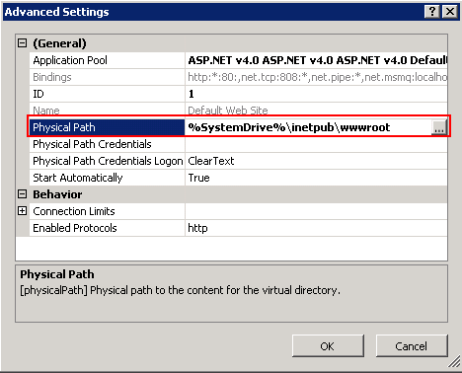

1. Click OK to accept the changes.
2. Copy the *inetpub* folder from the default location and paste it into the new drive as specified in the Physical Path.

In addition, the following process must be followed to ensure that the ChemBioOffice installers direct their output to the expected path:

1. Open the Registry Editor (Start > Run > RegEdit)
2. Expand the tree and navigate to:
   * HKEY_LOCAL_MACHINE\Software\Microsoft\InetStp (for 32-bit systems) OR
   * HKEY_LOCAL_MACHINE\Software\Wow6432Node\ Microsoft\InetStp (for 64-bit systems)
3. Right-click the PathWWWRoot value and click Modify.

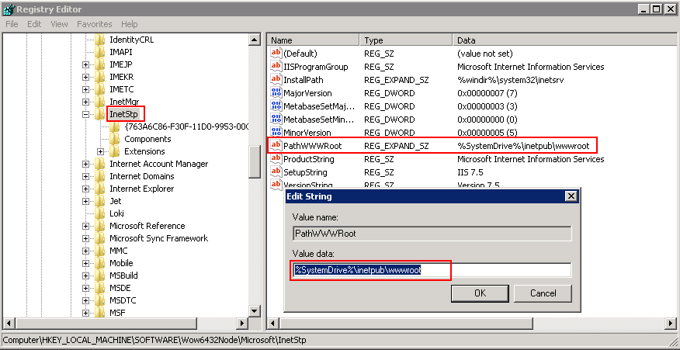

1. Enter the same value that was previously used for the Default Web Site local path.
2. Click **OK**.

## Enabling Secure Sockets Layer (SSL) and Installing SSL Certificate

Secure Sockets Layer is a protocol that provides secure communications on the Internet while exchanging sensitive information. If you enable SSL connections, ChemBioOffice application will force HTTPS (Hypertext Transfer Protocol Secure) when you access the ChemBioOffice application.

To configure SSL in IIS on a Windows machine, follow the steps mentioned below.

### Creating an SSL Certificate in IIS

To create an SSL Certificate in IIS:

| **Step** | **User Input/Action** | **Expected Results** |
| --- | --- | --- |
| 1. | Navigate to: **Start > All Programs > Administrative Tools > Internet Information Services (IIS) Manager**. | The IIS Manager opens. |
| 2. | Click on the name of the server in the Connections column in the left pane and double-click on **Server Certificates**. | Server Certificates page displays. |
| 3. | In the Actions column on the right pane, click **Create Self-Signed Certificate.** | The Create Self-Signed Certificate dialog box appears. |
| 4. | Enter a name for the certificate and click **OK**. |  |
| 5. | A new certificate is created as shown in the example below. |  |

### Binding the Certificate to a Website

To bind the certificate to a Website:

| **Step** | **User Input/Action** | **Expected Results** |
| --- | --- | --- |
| 1. | In the IIS Manager, in the Connections column on the left pane, expand the Sites folder and click on the website that you want to bind the certificate to.    Click on **Bindings** in the right pane. | Site Bindings window opens |
| 2. | Click **Add**. | The Add Site Binding dialog box appears. |
| 3. | Click **https** in the Type drop-down list and select the SSL certificate that you have created.    Click **OK**. |  |
| 4. | Click **Close** to close the Site Bindings window. |  |

### Installing SSL Certificate on your Web Browser

You need to add the SSL certificate to your Web browser on the Client machine to access the ChemBioOffice Enterprise application.

To install the SSL certificate on your Web browser:

| **Step** | **User Input/Action** | **Expected Results** |
| --- | --- | --- |
| 1. | Open your Web browser, and navigate to the following address:  [*https://*](https://localhost/DataLoader/Login.aspx)*<servername>/coemanager*   |  |  | | --- | --- | | ***NoteIcon*** | ***Note****: You must replace <servername> with the actual CBOE server name.* | |  |
| 2. | Click the certificate error displayed on the address bar to launch the *Untrusted Certificate* pop-up window.    In the *Untrusted Certificate* pop-up window, click **View Certificates**. | The Untrusted Certificate pop-up window appears. |
| 3. | Click **Install Certificate**, the Certificate Import Wizard appears. | The Certificate Import Wizard appears. |
| 4. | Click **Next**. |  |
| 5. | In the Certificate Store window, select *Place all certificates in the following store* option and click **Browse**. | The Select Certificate Store dialog box appears. |
| 6. | In the Select Certificate Store dialog box, select the **Show Physical stores** check-box, and select **Local Computer** under **Trusted Root Certification Authorities.**  **C**lick **OK**.    Click **Next**. |  |
| 7. | Click **Finish**. |  |
| 8. | Click **Yes** in the confirmation message that appears. |  |
| 9. | Click **OK**. |  |

### Configuration Tool – Server Settings for SSL Configuration

1. To launch the configuration tool, go to Start > **All** Programs > ChemBioOffice Enterprise > Server Configuration Tool.

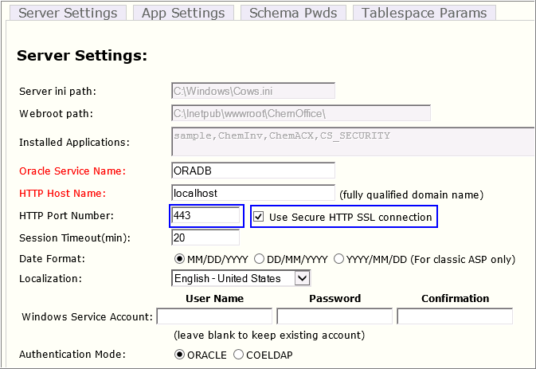

1. In the HTTP Port Number field, select the *Use Secure HTTP SSL Connection* check box. Make sure that the port number is 443.
2. Save and close the configuration tool.

### Updating SingleSignOnCom.dll.config File

To update the *SingleSignOnCom.dll.config* file:

1. Go to *C:\Program Files (x86)\PerkinElmer\ChemOfficeEnterprise\Common\dlls.*
2. Open *SingleSignOnCom.dll.config* for edit.
3. Change “*http*” to “*https*” as shown.

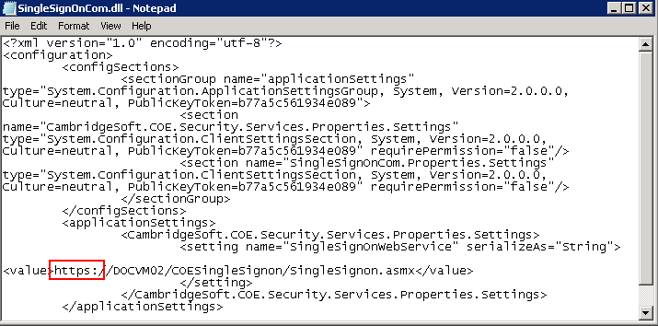

1. Save and close the file.
2. Application Server Installation

## Overview

This section describes the installation process for all components required to support the Web-based applications that are part of ChemBioOffice Enterprise 19.1. The installer for all components is provided with the ChemBioOffice Enterprise 19.1 distribution.

The installer controls the installation path for the programs and files that are getting installed. However, the destination location of some of the files such as asp, html, and gif are determined by the web root path of the IIS server and not by the installer target path. In case, if you want to avoid installing any files on the system volume (typically C:\), you need to first reconfigure the path of the Default Web Site web root as described in section Changing the Web Root Path.

The installers register services or IIS applications which must run under the credentials of an administrative user account. The installers will prompt for the user name and password of the windows account to be used. The installers can either create a new account or use an existing one. The account can be either a local account or a domain account, but in either case, it must belong to the local administrators group. It is strongly recommended that the chosen user be exempt from password expiration policies. Otherwise the system will need to be reconfigured each time the password expires.

***Note****: The installer may warn you about the need to close some open applications. In most cases, this warning can be safely ignored. It is typically not necessary to close those applications.*

***Note****: The CBOE 19.1 installer should be run using the actual administrator account.*

## Before Proceeding to Install

* Allow ISAPI and ASP.Net extensions

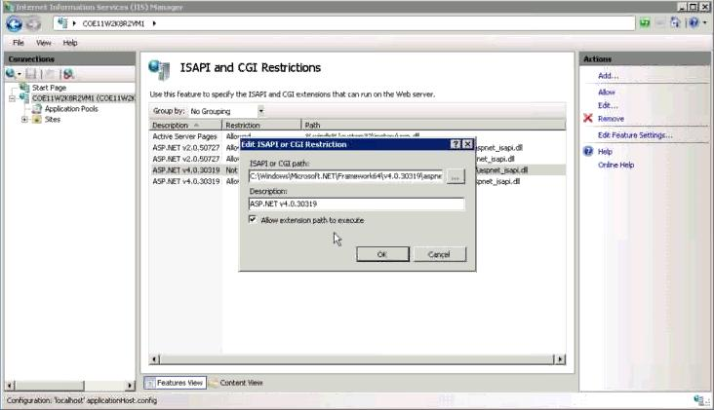

* Request filtering by removing the configuration file.

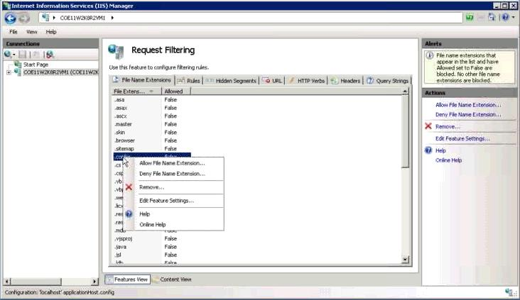

## Configuration Verification for Windows Server

Before installing CBOE, make sure to maintain the following recommended Server Manager Configuration settings.

### Accessing Server Manager Dashboard

1. Move the mouse pointer to the upper- right corner or lower-right corner of the screen, and click the **Start** icon from the Charms bar that appears.

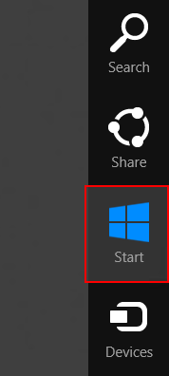

1. In the Windows Start screen that appears, click the **Server Manager** Icon.

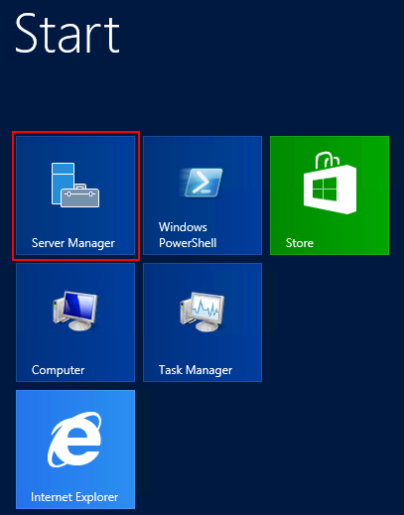

1. The Server Manager dashboard appears as shown below.

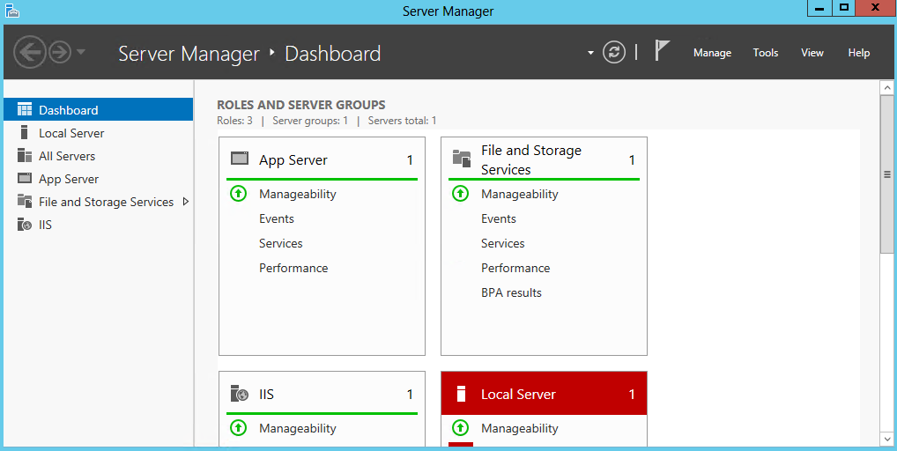

### Managing Roles and Features in Windows Server 2012

1. In the Server Manager dashboard, click **Manage > Add Roles** **and Features**.

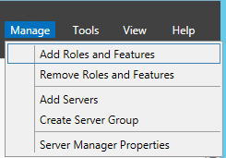

1. In the Add Roles and Features Wizard, click the **Server Roles** tab.
2. Expand **Application Server**.
3. Make sure that **Windows Process Activation Service Support** and all the options under it are selected as shown below.

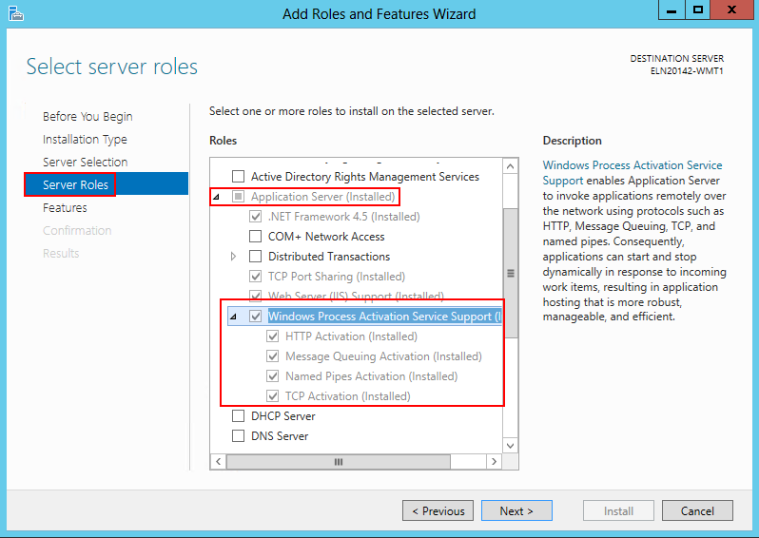

1. Expand **Web Server (IIS) > Web Server > Application Development**.
2. Verify that the options under Application Development are selected as shown below.

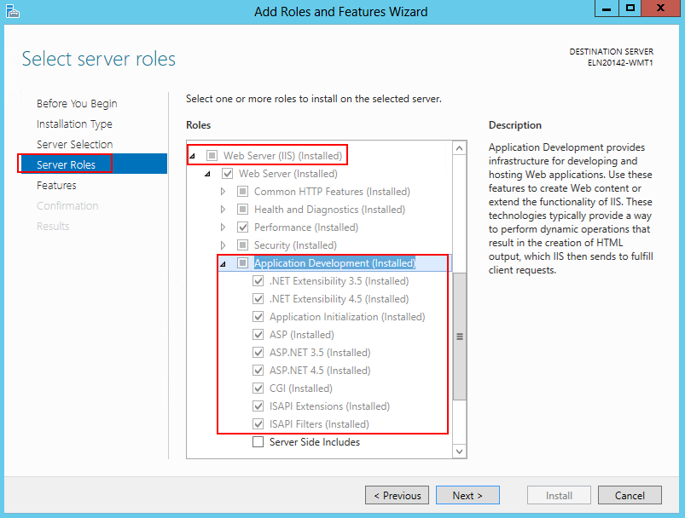

1. Click **Next** and click **Install** in the Confirmation window to install the selected features.

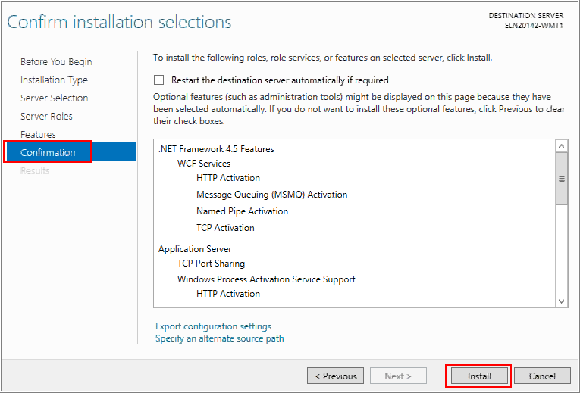

### Managing Roles and Features in Windows Server 2012 R2 and Windows Server 2016

1. In the Server Manager dashboard, click **Manage > Add Roles** **and Features**.



1. In the Add Roles and Features Wizard, click the **Server Roles** tab.

***Note****: If the* ***Server Roles*** *tab is disabled, you may click the* ***Next*** *button at the bottom of the window several times to reach the* ***Server Roles*** *tab.*

1. Expand **Web Server (IIS) > Web Server > Application Development**.
2. Verify that the options under Application Development are selected as shown below.

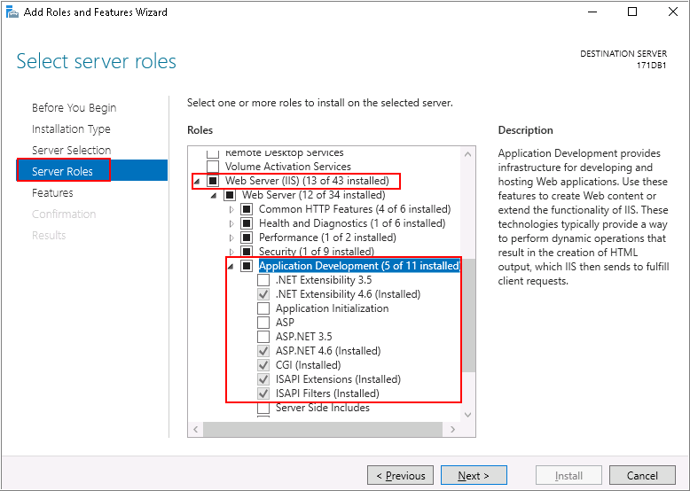

1. Click **Next** to get the **Features** tab.
2. Expand **.NET Framework 4.6 Features > WCF Services** and select the **HTTP Activation** check-box.

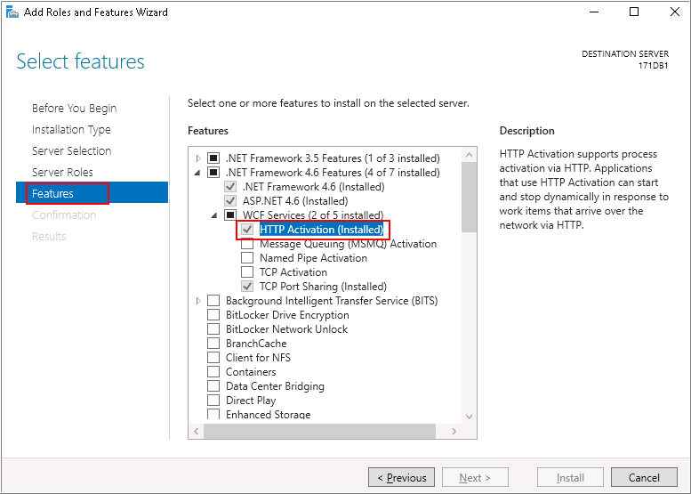

1. Click **Next** and click **Install** in the Confirmation window to install the selected features.

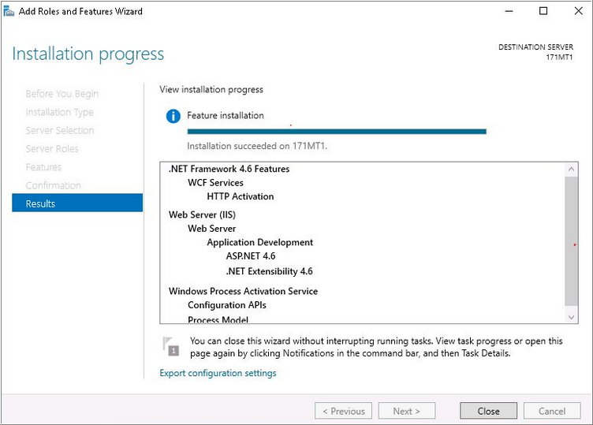

1. Click **Close**.

### Verifying the status of ASP.Net State Service

1. Open the Task Manager window and verify that the **ASP.Net State Service** is running as shown in the image below.

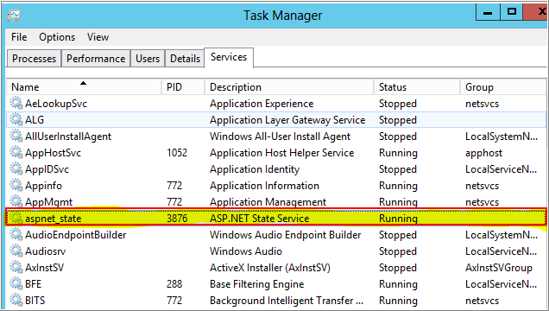

## Configuration Verification for IIS

If you are installing the CBOE server onto a middle tier system running IIS 7.x, IIS 8.x, or IIS 10.x, make sure that the IIS installation on the middle tier server has been configured with both the IIS 6 Management Compatibility and IIS 6 WMI Compatibility features installed.

To install the IIS 6.0 Management Compatibility Components on Windows Server by using the Server Manager tool:

* 1. Click **Start > Administrative Tools > Server Manager**.
  2. In the navigation pane, expand Roles, right-click Web Server (IIS), and click Add Role Services. The Add Role Services wizard appears.
  3. In the Select Role Services pane, scroll down to IIS 6 Management Compatibility.
  4. Click to select the *IIS 6 Metabase Compatibility* and *IIS 6 Management Console* check boxes.
  5. In the Select Role Services pane, click Next, and click Install at the Confirm Installations Selections pane.
  6. Click Close to exit the Add Role Services wizard.

The screen shots below provide complete information on the IIS features that should be enabled for CBOE19.1:

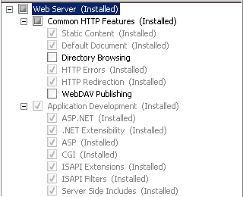

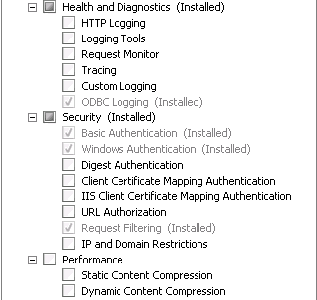

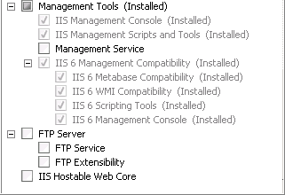

## Installing ChemBioOffice Enterprise 19.1

### Installation Prerequisites

To install CBOE 19.1, you must have .Net Framework 4.7.2, .Net Framework 4.7.1, or .Net Framework 4.7 installed on your machine.

### Installing CBOE 19.1

Follow the steps below to install ChemBioOffice Enterprise Suite:

| **Step** | **User Input/Action** | **Expected Results** |
| --- | --- | --- |
| 1 | Launch the *CBOE 19.1.exe* installer. The CBOE installer wizard displays  Click **Install**.  **Note**: This installer wizard lists the prerequisites which are not installed on your machine. When you click Install, it begins installing the items listed. You may need to follow the on-screen instructions to complete the installation of the prerequisite items. | Installation begins and the welcome wizard appears. |
| 2 | Click **Next**. | CBOE 19.1 License Agreement window appears. |
| 3 | Read the license agreement, and select the “I accept the terms in the license agreement” option.    Click **Next**. | Website selection window appears |
| 4 | Select one of the following options:  Select existing Website (Recommended)    Create a new Website   * Website Description: Enter the name of the new Website. (ChemOfficeEnterprise by default) * IP Address: Select the IP Address from the dropdown list. * Port No: Enter the Port Number * Host Header: Optionally enter the host header     **Note**: Microsoft Internet Information Services (IIS) allows you to map multiple Web sites with the same port number to a single IP address by using a feature called Host Header Names. By assigning a unique host header name to each Web site, this feature allows you to map more than one Web site to an IP address.  The host header is the hostname that users will enter into their browser when trying to reach this server via HTTP. That is, the name of the server that user will enter into their web browser when trying to reach the ChemBioOffice Enterprise applications. It is the responsibility of the network administration to ensure that the host header resolves to the IP address bound to the Default Web Site. The same host header must not be used by any other web site sharing the same target IP address. | Website selection window dismisses, then the selection of CBOE installation destination folder window appears |
| 5 | If required, click **Change** to change the default destination location and to select a new destination folder.  Enter the Oracle Service Name and click **Next**. | The selection of CBOE installation destination folder window dismisses, then the user creation window appears |
| 6 | Enter the credentials for the Windows account used to run PerkinElmer services. This can be an existing local or domain administrative account. The installer can create a new account if desired.  The default is to create an account named camsoft_admin with password CambridgeS0ft!    **Note**: Depending on the password complexity policy in effect, this default password may not be acceptable. Please remember the user name and password chosen in this step for later use. | The user creation dialog dismisses and *Setting ChemDraw JS*  window displays |
| 7 | Select the protocol type and configure other respective settings.    **HTTP**:   * Type: Protocol type: http or https. The type has to be set to https if the host applications are using https. * Host name: Enter the local server machine name or IP address: local machine name as default. * Port: Port number of the service. * Virtual path: Virtual path of the service.   **HTTPS**:   * SSL certificate: SSL certificate: Click Select to add a SSL certificate .pfx file. * SSL password: SSL certificate file password: Enter the password of SSL certificate.   Click **Next**. | The *Setting ChemDraw JS*  dialog dismisses and *Ready to Install the Program* window displays |
| 8. | Click Install. | Installation starts. |
| 9. | After the installation is completed, click **Finish** to close the installer window. | Install shield wizard closes. |
| 10. | Click **Yes** in the confirmation window to restart the application server. |  |

### Configuration Changes for CFServerASP Application in IIS

A new mime type with extension .json and type - application/json should set for `CFServerASP` application in IIS as described below.

**To configure a new mime type for CFServerASP application**

1. In the Search box, type ***inetmgr*** and press <Enter> to access the *Internet Information Services (IIS) Manager* console.
2. In the IIS Manager, expand the **local computer > Sites > Default Web Site**.
3. Click **CFServerASP**, and double-click **MIME Types**.

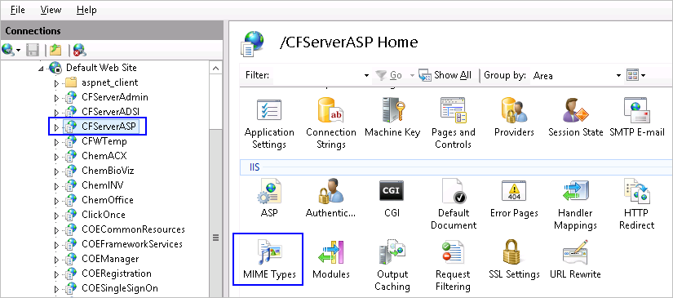

1. Click **Add**, and in the *Add MIME Type* window, enter the *File name extension* as **.json** and *MIME type* as **application/json**.

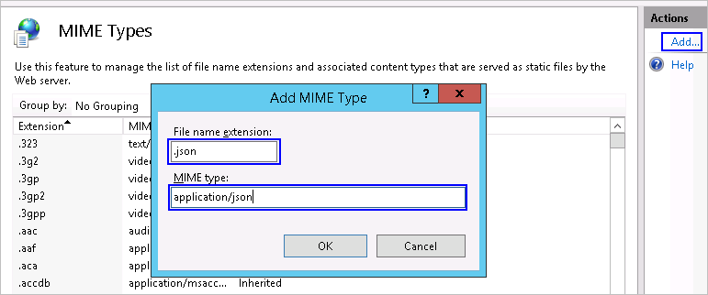

1. Click **OK**.

**To add the json type in the mapping handlers**

1. In the IIS Manager, expand the **local computer > Sites > Default Web Site**.
2. Click **CFServerASP**, and double-click **Handler Mappings**.

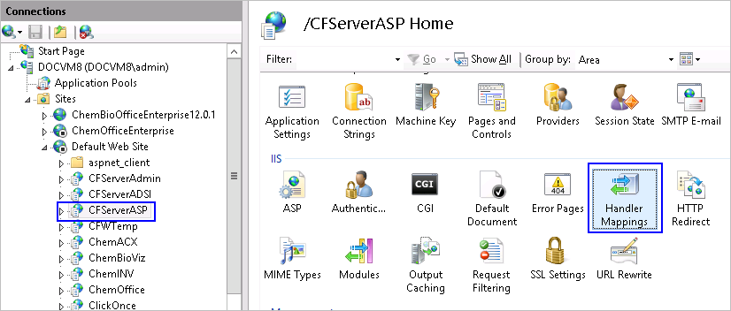

1. Click **Add Script Map**, and in the *Add Script Map* window, enter the *Request path* as **\*.json**, *Executable* as **C:\WINDOWS\system32\inetsrv\asp.dll** (If **asp.dll** is in a difference location, you may need to browse the location of the file), and *Name* as **json**.

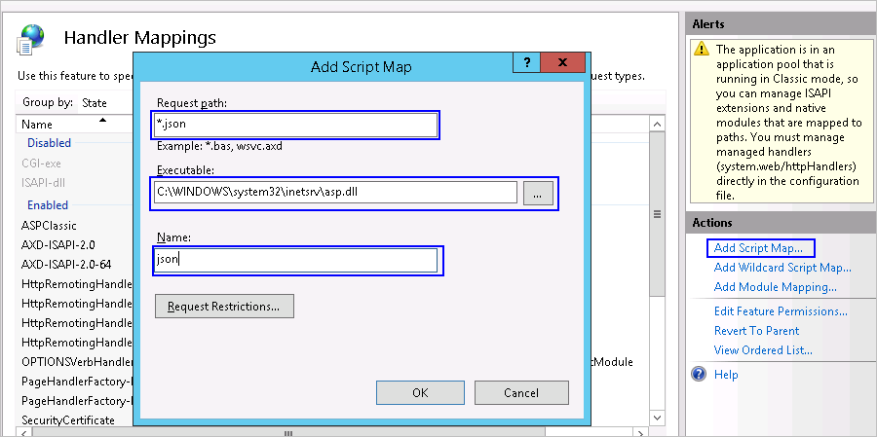

1. Click **OK**.
2. Perform an IISRESET.

## Installing ChemACX

The ChemACX application supports the use of Oracle based database. Please note that a free disk space of approximately 160GB is required for the ChemACX 19.19.1 installation in CBOE 19.1.

### ChemACX Oracle Based Database

The ChemACX Oracle requires that the contents of the ChemACX Oracle scripts as well as the dump file distributed on a separate CD, be extracted and copied to: <webroot>\ChemOffice\ChemACX\config\oracle_installation_scripts.

**Note**: After installing the ChemACX database, the chemacx.udl file should be updated. For detailed instructions please refer to the "*OracleSetup.hta*" file that can be found in the installation folder.

## Activate ChemDraw Professional

A copy of ChemDraw Professional 2018 is installed on the Application Server in order for all other modules to function. You need to activate the ChemDraw Professional by providing user and serial number information:

| **Step** | **User Input/Action** | **Expected Results** |
| --- | --- | --- |
| 1 | Go to **Apps** > **ChemDraw 18.1.** | The *PerkinElmer Software Activation* window appears. |
| 2 | Enter your Name, Organization, Email address and the Serial Number provided by PerkinElmer. |  |
| 3 | Enter the Activation Code provided by PerkinElmer or click the “Activate over Internet”. The activation code will be retrieved from PerkinElmer server via the Internet. If the server cannot gain access to the internet then you will need to obtain the activation code associated with your serial number from PerkinElmer technical support. |  |

## Activate ChemScript

ChemScript is installed on the Application Server in order for all other modules to function. You need to activate the ChemScript by providing user and serial number information:

| **Step** | **User Input/Action** | **Expected Results** |
| --- | --- | --- |
| 1 | Go to **Start > ChemOffice 2018 > ChemScript Demo**. |  |
| 2 | In the command window, follow the prompts until the PerkinElmer Software Activation window appears. |  |
| 3 | Enter your Name, Organization, Email address and the Serial Number provided by PerkinElmer |  |
| 4 | Enter the Activation Code provided by PerkinElmer or click the “Activate over Internet”. The activation code will be retrieved from PerkinElmer server via the Internet. |  |
| 5 | Close the ChemScript Demo command window. |  |

1. Database Schema Creation

## Overview

The Oracle schemas required by the ChemBioOffice WebServer application modules are created or updated by executing SQL scripts from the application server. If all software requirements have been met then the application server will be already properly configured to execute scripts against the database using the Oracle SqlPlus command line utility. The necessary SQL scripts are delivered to the application server as part of each application module installer. In addition, the Core ChemBioOffice Enterprise installer delivers Database Creation and Upgrade Guides which provide convenient hyperlinks from which to launch the SQL scripts. Clicking a hyperlink from the Upgrade or Creation Guide launches the corresponding script in SQLPlus. SQLPlus will prompt for the necessary input such as:

* Name of the target Oracle service
* Name of an account with Oracle DBA privileges (typically the “System” account)
* Password for the above account

**Note:** It is recommended that the database scripts be executed using the system account and that its password be temporarily changed to “manager2”. These are the default values used by most scripts. Doing this will minimize typing and expedite the installation process. The system password can be changed at the end of the database installation process and the final password used during the configuration steps detailed below.

Each SQL script will produce a detailed log file of the actions taken while creating or updating the target database, as well as a summary log file which contains a count of errors, ignorable errors, and actions performed. The summary log file is automatically open upon completion of the SQL script execution.

A copy of each summary and detailed log files is stored at:

*C:\Program Files (x86)\PerkinElmer\ChemOfficeEnterprise\Configuration and DB Tools\SetupLogs*

While executing the scripts, you may get the following ignorable errors. It is absolutely safe to ignore the errors.

* PLS-00302: component must be declared
* ORA-00955: name is already used by an existing object
* ORA-12003: materialized view or zonemap does not exist
* ORA-00942: table or view does not exist
* ORA-00001: unique constraint violated
* ORA-12002: there is no materialized view log on table
* ORA-01418: specified index does not exist

Most creation and upgrade scripts will yield a zero error count in the summary log. However, depending on the order in which the scripts are executed or on the previous database upgrade history, it is possible that some scripts will yield a non-zero error count. In this event, the “ignorable” error counts provided in the summary log should be inspected. If the sum of ignorable errors matches the total error count, then the script execution can be considered successful. If the error count is higher than the sum of ignorable errors, then the script execution should be considered unsuccessful. The cause of the unexpected errors should be investigated and resolved before continuing with the execution of other SQL scripts. The detailed log often contains the necessary information to pinpoint the cause of unexpected errors.

## Database Schema Creation

***Note:*** *If CBOE is installed with Oracle 11g or 12c, then CBOE classical applications (inventory, ChemACX) should have the udl username/password in CAPITAL. For more information on how to make the password case-insensitive please refer to the section* *13.5 Oracle 11g or 12c Related Issues**.*

The ChemBioOffice Enterprise 19.1 Database Creation Guide provides hyperlinks to launch each of the database creation scripts.

To launch the Database Creation Guide, click Start > ChemBioOffice Enterprise > Database Creation Scripts

The following page appears:

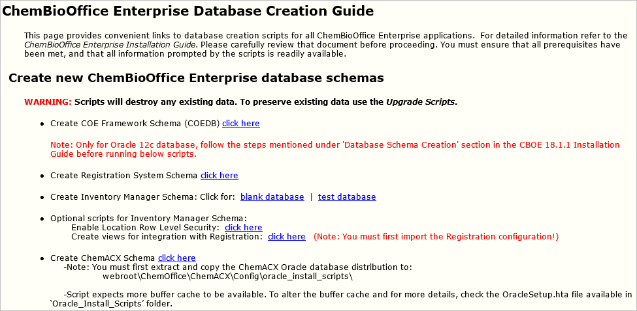

Click each of the links to create the corresponding database. The COE Framework Schema script is the only one required for all installations. The other creation scripts should be executed (in the order in which they appear on the page) if the corresponding application module was previously installed. Clicking a hyperlink to launch a script for an application that has not been installed will result in an error.

Unexpected errors found while executing any update script should be resolved before executing additional scripts. A copy of all log files in the SetupLogs folder should be submitted to PerkinElmer support for troubleshooting of the database creation errors.

### COE Framework Schema

The COE Framework Schema script is the only one required for all installations.

|  |  |
| --- | --- |
| **Script Prompt** | **Description** |
| Enter the target Oracle service name: | Enter the name of the target Oracle service. This is the same name that should have been tested in section TNS Names Configuration. |
| Enter the name of an Oracle account with system privileges (system): | If your oracle account with system privileges is ***system****,* click Enter. For another one, enter the name of the oracle account. |
| Enter the above oracle account password (manager2): | If system password has been temporarily changed to “manager2”, click Enter. For another one, enter the system password. |

After the execution of this script, the summary log appears. Be sure Errors is equal to zero. If not, open and inspect the following log file *LOG_CREATE_COEDB_ORA.TXT* using the shortcut at Start > ChemBioOffice Enterprise > Setup Logs.

* + - 1. Steps to be Done in Oracle 12c Fresh Environment

You need to perform the following steps on an Oracle 12c fresh machine.

1. After creating the COEDB schema through DB creation scripts, open a separate command prompt and login to sqlplus as SYS user:  
   e.g.  
   Enter user-name: sys@<oracle service Id> as sysdba  
   Enter password: <password for SYS user>
2. Once connected successfully, execute: alter system set "_projection_pushdown" = false scope=both;
3. Execute : grant select on sys.user$ to COEDB;
4. If its granted successfully, connect the sqlplus as COEDB user:  
   eg: connect coedb/<coedb schema password>@<oracle service id>
5. Once connected successfully, run the below statement:  
   @"C:\Program Files (x86)\PerkinElmer\ChemOfficeEnterprise\Framework\DBInstallScripts\COEDB\Oracle_Install_Scripts\sql\Patches\Patch 12.6.3\Function\fn_CreateUser.sql";
6. Make sure the function is created without any compilation errors.
7. Continue creating the rest of the CBOE schemas through DB creation scripts.

### Registration System Schema

Registration System is a powerful, web-based registration solution included in the ChemOffice Enterprise suite. The system includes a robust data model for pure compounds, mixtures, batches, salt management, automatic duplicate checking, and unique ID assignments.

To create the Registration System schema click the *Click Here* hyperlink from the Create Registration System Schema and respond to the script prompts:

|  |  |
| --- | --- |
| **Script Prompt** | **Description** |
| Enter the target Oracle service name: | Enter the name of the target Oracle service. This is the same name that should have been tested in section TNS Names Configuration. |
| Enter the name of an Oracle account with system privileges (system): | If your oracle account with system privileges is ***system****,* click Enter. For another one, enter the name of the oracle account. |
| Enter the above oracle account password (manager2): | If system password has been temporarily changed to “manager2”, click Enter. For another one, enter the system password. |

After the execution of this script, the summary log appears. Be sure Errors is equal to zero. If not, open and inspect the following log file *LOG_CREATE_CHEMREG_ORA.TXT* using the shortcut at Start > ChemBioOffice Enterprise > Setup Logs.

***Note****: While creating REGDB schema for a fresh installation, you may encounter ignorable errors in the log file as shown in the image. This is because of the performance improvement conducted on InvLoader, wherein some of the indexes were created under the system user and not under the regdb user. To fix this, we dropped the indexes created under the system user and recreated those under regdb user. This change is integrated into both 12.5.3 and 12.6. Since these scripts are included in both 12.5.3 and 12.6, you may get these errors. You can ignore these errors***.**

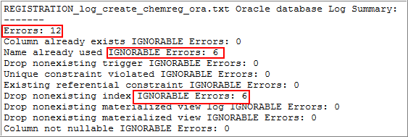

### Inventory Manager Schema

Inventory Enterprise is a ChemBioOffice Enterprise application that allows you to track the data associated with the reagents procured or produced by chemical and pharmaceutical research centers. It keeps track of all the data from the procurement or initial production of the reagents to the depletion or disposal of the reagents.

You can create a blank Inventory database with no data inside or a test Inventory database which load automatically a test database for test purpose.

***Note****: Before running the Inventory Manager schema, it is mandatory that you need to execute the Registration System schema to avoid any Oracle errors even though you are not using Registration.*

If you want to create a blank database click the *Blank Database* hyperlink, otherwise click *Test Database* from the Inventory Manager Schema section and respond to the script prompts:

***Note****: For* ***Test Database****, make sure that you have already installed both ODAC and Oracle client on the middle tier machine to avoid any ORA errors while executing the script.*

|  |  |
| --- | --- |
| **Script Prompt** | **Description** |
| Blank Database | |
| Enter the target Oracle service name: | Enter the name of the target Oracle service. This is the same name that should have been tested in section TNS Names Configuration. |
| Enter the name of an Oracle account with system privileges (system): | If your oracle account with system privileges is ***system****,* click Enter. For another one, enter the name of the oracle account. |
| Enter the above oracle account password (manager2): | If system password has been temporarily changed to “manager2”, click Enter. For another one, enter the system password. |
| Test Database | |
| Enter the target Oracle service name: | Enter the name of the target Oracle service. This is the same name that should have been tested in section TNS Names Configuration. |
| Enter the name of an Oracle account with system privileges (system): | If your oracle account with system privileges is ***system****,* click Enter. For another one, enter the name of the oracle account. |
| Enter the above oracle account password (manager2): | If system password has been temporarily changed to “manager2”, click Enter. For another one, enter the system password. |

After the execution of this script, the summary log appears. Be sure Errors is equal to zero. If not, open and inspect the following log file *LOG_CREATE_BLANK_CHEMINVDB.TXT or LOG_CREATE_TEST_CHEMINVDB.TXT* using the shortcut at Start > ChemBioOffice Enterprise > Setup Logs.

Additional, Inventory Manager optionally supports the use of Oracle Row Level Security to prevent users or groups from accessing protected inventory locations. This feature is enabled by executing a database script that defines the Oracle Fine Grained Access Control policies. Click the Enable Location Row Level security hyperlink option, to execute this database script:

|  |  |
| --- | --- |
| **Script Prompt** | **Description** |
| Enter the target Oracle service name: | Enter the name of the target Oracle service. This is the same name that should have been tested in section TNS Names Configuration. |
| Enter the name of an Oracle account with system privileges (system): | If your oracle account with system privileges is ***system****,* click Enter. For another one, enter the name of the oracle account. |
| Enter the above oracle account password (manager2): | If system password has been temporarily changed to “manager2”, click Enter. For another one, enter the system password. |

After the execution of this script, the summary log appears. Be sure Errors is equal to zero. If not, open and inspect the following log file LOG_ADDRLS.TXT using the shortcut at Start > ChemBioOffice Enterprise > Setup Logs.

**Note**: If location-based security is enabled, reporting in Inventory may not work correctly.

The Inventory Manager optionally supports integration with PerkinElmer’s Registration Enterprise system. This is a by-directional integration where the Inventory System can search and display registered compounds and the Registration system can create Inventory containers to track registered substances.

***Note****: This script needs to be run only after importing the Registration configuration as described in section 9.1* *Importing Chemical Registration Configuration**.*

The Inventory Manager accesses the Compound and Batch data stored in the Registration System via a set of Oracle views created in the Inventory database schema. A SQL script is provided to create the views. The views can be modified under the direction of PerkinElmer Service Engineers to expose registration data from other sources.

To execute the default Registry Integration scripts, click the *Create views for integration with Registration* hyperlink.

|  |  |
| --- | --- |
| **Script Prompt** | **Description** |
| Enter the target Oracle service name: | Enter the name of the target Oracle service. This is the same name that should have been tested in section TNS Names Configuration. |
| Enter the name of an Oracle account with system privileges (system): | If your oracle account with system privileges is ***system****,* click Enter. For another one, enter the name of the oracle account. |
| Enter the above oracle account password (manager2): | If system password has been temporarily changed to “manager2”, click Enter. For another one, enter the system password. |

After the execution of this script, the summary log appears. Be sure Errors is equal to zero. If not, open and inspect the following log file LOG_REGISTRATIONINTEGRATION.TXT using the shortcut at Start > ChemBioOffice Enterprise > Setup Logs.

### ChemACX Schema

ChemACX (Available Chemicals Exchange) is a large database of chemical products that are currently available from chemical manufacturers and distributors. Before launching ChemACX scripts, be sure scripts and dump file are copied as described in *ChemACX Oracle based database* chapter*.*

*ChemACX scripts require that 4k and 16K buffer cache be available on the target database instance. The ChemACX schema hyperlink should not be used unless these requirements have been met.*

***Note****: The buffer cache size and minimum disk size required varies based on the ChemACX Database version you are installing. For more information, refer the OracleSetup.hta file available under <webRoot>wwwroot\ChemOffice\ChemACX\config\Oracle_Install_Scripts.*

***Note****: To increase the cache size please follow the below steps:*

* *Connect sys/<syspwd>@<schema> as sysdba*
* *Alter system set db_4k_cache_size=64M scope=spfile;*
* *Alter system set db_16k_cache_size=16M scope=spfile;*
* *Shutdown the system*
* *Startup*

To create the ChemACX schema click the *click here* hyperlink and respond to the script prompts:

|  |  |
| --- | --- |
| **Script Prompt** | **Description** |
| Enter the target Oracle service name: | Enter the name of the target Oracle service. This is the same name that should have been tested in section TNS Names Configuration. |
| Enter the name of an Oracle account with system privileges (system): | If your Oracle account with system privileges is ***system****,* click Enter. For another one, enter the name of the oracle account. |
| Enter the above Oracle account password (manager2): | If system password has been temporarily changed to “manager2”, click Enter. For another one, enter the system password. |

After the execution of this script, the summary log appears. Be sure Errors is equal to zero. If not, open and inspect the following log file log_create_chemacx.txt using the shortcut at Start > ChemBioOffice Enterprise > Setup Logs.

## Verification of Database Parameters

After executing the database creation scripts, you need to verify that the parameters are correct as described below.

**To verify the parameters:**

1. Connect to the database, and execute the script *show parameter mv;*
2. Check whether it returns the values as shown below.

|  |
| --- |
| SQL> show parameter mv; |
| NAME                                 TYPE        VALUE |
| ------------------------------------ ----------- ------------------------------ |
| _mv_refresh_use_no_merge             **boolean**     FALSE |
| _mv_refresh_use_stats                **boolean**     TRUE |
| SQL> |

1. If the script does not return the values as shown, execute the following scripts to configure the values.

|  |
| --- |
| alter system set "_mv_refresh_use_no_merge" = **false** scope=both; |
| alter system set "_mv_refresh_use_stats" = **true** scope=both; |

1. Application Server Configuration

## Overview

ChemOffice WebServer applications are highly configurable. Configuration settings are managed via initialization files (.ini) and database link files (.udl). There are some common configuration steps which are required for all application modules, such as providing the target database information or connection credentials. There are many other, application specific, optional configuration steps which control the behavior of detailed aspects of each module. All configuration files are human readable and can be edited using a simple text editor. However, the most common configuration tasks can be most easily accomplished using the ChemBioOffice Enterprise 19.1 Configuration Tool. This section provides an overview of the various configuration files. The next section provides details on the use of the Server Configuration Tool.

## Configuration Files

### COEFrameworkConfig.xml

This file is located in the C:\ProgramData\PerkinElmer\ChemOfficeEnterprise\ folder. It is created by the core ChemBioOffice Enterprise installer and records configuration information required by the COE Framework services, including database connection details, SingleSignOn URL and authentication configuration. This file is automatically updated by the installer and the server configuration tool. It does not need to be manually edited for most common installation scenarios.

### COWS.ini

This file is located in the windows folder (typically C:\Windows or C:\WinNT). It is created by the core ChemBioOffice Enterprise installer and records the physical path to the ChemOffice folder under which all other modules are located. This file does not need to be modified unless the location of the ChemOffice folder needs to be changed after the initial installation. Relocating the ChemOffice folder requires adjusting many other configuration settings so is strongly recommended that this task only be performed under the direction of an experienced PerkinElmer service engineer.

### ChemOffice.ini

This file is located is located under the ChemOffice root (typically *C:\Inetpub\wwwroot\ChemOffice\Config*). It contains server level settings such as the list of installed application modules, the authentication method in effect, the version of ChemOffice desktop components present on the server, and the version of the ChemBioOffice Enterprise core. This file is created by the ChemBioOffice Enterprise installer and it is updated by each of the application modules installers. The configuration tool described below interacts with this file to setup the version of desktop components to be used. This file does not typically need to be manually edited.

### Cfserver.ini

This file is located in each application’s configuration folder (typically *C:\Inetpub\wwwroot\ChemOffice\<appName>\config*). It contains application level configuration information. There are three main sections in the cfserver.ini file. The [GLOBALS] and [CS_SECURITY] sections contain configuration settings that are available in all application modules. A third section typically named after the specific application (Ex. [CHEMINV]) contains configuration settings for application specific features. The mandatory and most commonly used settings in this file are managed by the configuration tool. Further customizations must be performed using a text editor under the supervision of a PerkinElmer service engineer.

### <AppName>.in

This file is located in each application’s configuration folder (typically *C:\Inetpub\wwwroot\ChemOffice\<appName>\config*), and is named after the application or database name. It contains information about the application database such as the names of database tables and fields, the relationships between tables, the data types of the fields, the expected behavior of data fields during query operations, and the database connection information. This file contains all the metadata required for ChemBioOffice Enterprise to dynamically generate the SQL required to interact with the database. These files do not typically need to be modified during deployment. They are authored and managed by the application developers as new objects are introduced into the database or as new query functionalities are added to the application. The only scenario under which this file may be modified on a deployed system would be the modification of the query behavior of an existing field. This task should be performed under the direction of a PerkinElmer service engineer.

### Custom Configuration Files

The ChemACX and Inventory Manager Application modules contain additional custom configuration files which extend the configurability afforded by the cfserver and application ini files. These files are also located in the application’s configuration folder.

ChemACXConfig.ini and InvConfig.ini are extensions of the corresponding application cfserver.ini files. Some of their most typically commonly used entries are managed by the Configuration tool. For more advanced settings they must be manually edited.

Other custom files such as invReg.ini, invAcx.ini and ChemACX2.ini are database metadata files similar to the <AppName>.ini. They contain the necessary information for more advanced global search features available in some applications. These files are also managed by the development teams and are not expected to be modified on the field.

### Database Link Files

ChemBioOffice Enterprise application modules use Microsoft OLEDB database link files to determine the database provider and service name used to establish the database connection. These files are located in each application configuration folder (typically *C:\Inetpub\wwwroot\ChemOffice\<appName>\config*). Udl files can be manually edited by double-clicking from the Windows Explorer. The operating system automatically provides a custom editor dialog that allows the selection of the provider and target service. Each application contains one of more udl files, but in most common scenarios, all applications will connect to the same back-end database. The ChemBioOffice Enterprise configuration tools will automatically set the service name for all of the installed module’s udl files, eliminating the need to repetitive manual configuration.

## Configuration Tool

While all configuration of the files described above may be performed by directly editing the files with a simple text editor, ChemBioOffice Enterprise 19.1 provides a configuration tool that can greatly simplify the most common configuration tasks.

The configuration tool detects the installed application modules and edits their configuration files. It is therefore important that the tool be run only after all desired modules have been installed. Application modules installed after the configuration tool has been run will not be affected by the configuration choices.

***Note:*** *Before launching the Server Configuration Tool make sure the Inventory system data sources (DSNs) is configured.*

### Launching the Configuration Tool

To launch the configuration tool go to Start > **All** Programs > ChemBioOffice Enterprise > Server Configuration Tool. The following page appears.

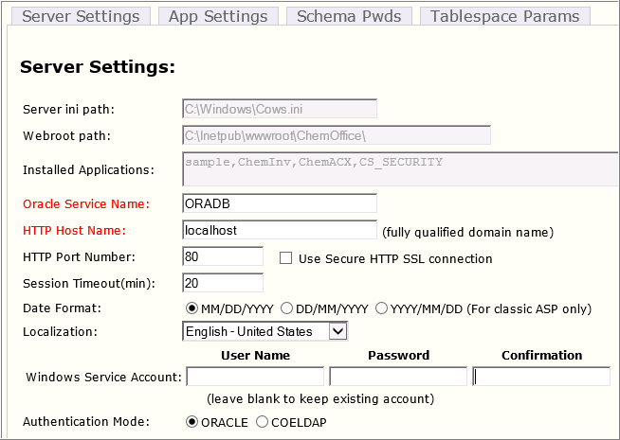

There are four tabs separating the major areas of configuration supported by the tool. Each tab is detailed in the following sections:

### Server Settings

Upon startup, the configuration tool detects the Cows.ini file path, ChemOffice webroot, and the list of installed applications. This information is presented in the tool, but it is not editable. Only application modules which appear in the list will be affected by the configuration tool. Before proceeding with any configuration choices please ensure that all desired modules have been installed.

The tool also checks for the presence of the ODBC DSNs that should have been setup as described in section ODBC Client Configuration. A warning will be issued if a connection cannot be established to the database.

The following configuration options appear on this section:

| **Fields** | **Description** |
| --- | --- |
| Oracle Service Name (required) | The name of the target Oracle service must be provided. This is the same name that should have been tested in section TNS Names Configuration. The tool will attempt to connect to the server before saving the configuration so the database must be available. |
| HTTP Host Name (required) | The application server host name or IP address must be entered here. The tool auto-detects the server name, however, it is recommended that this name be replaced with the DNS managed host name that will be used by the end users when accessing the application server. The recommended practice would be to setup a DNS entry pointing the application server using a fully qualified descriptive name such as ChemBioOfficeEnterprise19.1.YourDomain.com. |
| HTTP Port Number | Set the HTTP Port number and HTTPS port number as shown in the figures below to enable the secured Internet services for the server.   * For HTTP, Port Number should be 80 * For HTTPS, the Port Number should be 443   Click on the check box “Use Secure HTTP SSL Connection” which shown in the figure for SSL certification. |
| Date Format | Select the desired date format. The chosen format will be used whenever dates are displayed or entered into the system. This setting affects all Oracle based ChemOffice WebServer applications which provides finer control of data formats on a per field level. If different formats are desired for different application modules then the applicable DATE_FORMAT entry in cfserver.ini file would need to be modified. |
| **Localization** | Localization is used to select the region option that should be consistent with the regional language setting of the Operating System, supporting the local characters, number |
| Service Account | The service account was determined during installation of the ChemBioOffice Enterprise core. If you wish to reconfigure all application modules to use a different service account, a user name and password should be provided here. The credentials are validated by the tool upon entry. The user account can be a local windows account or a domain account (EX. myDomain\myUser). Leave this section blank to preserve the service account defined during installation. |
| Authentication Mode | ORACLE User credentials are authenticated against Oracle. User must have a valid Oracle account and know its password. No additional configuration is required in this case.  COELDAP User credentials are authenticated against the ChemOffice Enterprise SingleSignOn Service. The service is typically configured to connect to a Microsoft Active Directory or LDAP server for authentication. An Oracle account also exists for the user but its password is internally managed by the application and not known to the end-user. |

When COELDAP option is chosen, a valid COELDAP configuration xml file fragment must be provided. An example is given below together with the explanation of the parameters that typically need to be adjusted to the local LDAP environment.

|  |
| --- |
| C:\temp\New Text Document.xml - # <COELDAPConfiguration>  C:\temp\New Text Document.xml - # <COELDAP>  C:\temp\New Text Document.xml - # <addUser>  C:\temp\New Text Document.xml - #<process>  C:\temp\New Text Document.xml - # <bind pwdRequired="true" authenticationType="secure">  <basedn> LDAP SERVER: LDAP PORT/dc=DOMAIN,dc=com</basedn>  <error>Failed to bind to domain</error>  </bind>  C:\temp\New Text Document.xml - # <query timeOut="2" scope="subTree" pageSize="5">  <filter>(sAMAccountName=%username%)</filter>  <attr>cn</attr>  <error>The username %username% was not found in the domain</error>  </query>  <unbind />  </process>  </addUser>  C:\temp\New Text Document.xml - # <authenticate>  C:\temp\New Text Document.xml - # <process>  C:\temp\New Text Document.xml - # <bind pwdRequired="true" authenticationType="secure">  <basedn>LDAP SERVER: LDAP PORT/dc=DOMAIN,dc=com</basedn>  <error>Failed to bind to domain</error>  </bind>  C:\temp\New Text Document.xml - # <query timeOut="2" scope="subTree" pageSize="5">  <filter>(sAMAccountName=%username%)</filter>  <attr>dn</attr>  <error>The username %username% was not found in the domain</error>  </query>  C:\temp\New Text Document.xml - # <bind pwdRequired="true" authenticationType="fastbind">  <basedn>boron2.camsoft.com</basedn>  <dn> DOMAIN\%username%</dn>  <error>Authentication Failed, process two</error>  </bind>  </process>  </authenticate>  C:\temp\New Text Document.xml - # <getUserInfo>  C:\temp\New Text Document.xml - # <process>  C:\temp\New Text Document.xml - # <bind pwdRequired="true" authenticationType="secure">  <basedn> LDAP SERVER: LDAP PORT/dc=DOMAIN,dc=com</basedn>  <error>Failed to bind to domain</error>  </bind>  C:\temp\New Text Document.xml - # <query timeOut="2" scope="subTree" pageSize="5">  <filter>(sAMAccountName=%username%)</filter>  <attr>SAMAccountName</attr>  <attr>givenName</attr>  <attr>initials</attr>  <attr>sn</attr>  <attr>mail</attr>  <error>The username %username% was not found in the domain</error>  </query>  <unbind />  </process>  </getUserInfo>  <ldapUserDN>cn=SERVICE ACCOUNT,cn=users,dc=DOMAIN,dc=com</ldapUserDN>  <ldapPass>ACCOUNTPASSWORD</ldapPass>  C:\temp\New Text Document.xml - #<GetUserReturnInfo>  <add ldapCode="SAMAccountName" displayName="Username" mapTo="username" nodeName="username" />  <add ldapCode="givenName" displayName="First Name" mapTo="FirstName" />  <add ldapCode="initials" displayName="Middle Name" mapTo="MiddleName" />  <add ldapCode="sn" displayName="Last Name" mapTo="LastName" />  <add ldapCode="mail" displayName="Email" mapTo="Email" />  </GetUserReturnInfo>  </COELDAP>  </COELDAPConfiguration> |

LDAP Server  
The name or IP address of the target LDAP or Active Directory Server. (Ex. myLDAP.myDomain.com)

LDAP Port

The TCP/IP port used by the LDAP server. Default value is typically 389.

Domain  
The Domain hosting the Active Directory.

Service Account  
The account used to connect to the Active Directory in order to authenticate the end users.

Account Password  
The password for the above account.

The expressions inside the <filter> tags can also be adjusted to fit the requirements of the local LDAP environment. The filter expression within the <adduser> section is applied to determine which LDAP users are valid to add to the system. The expression within the <authenticate> provides the filter to reach the desired user to be authenticated.

### Application Settings

This section allows for the configuration of the most commonly used options for each of the application modules:

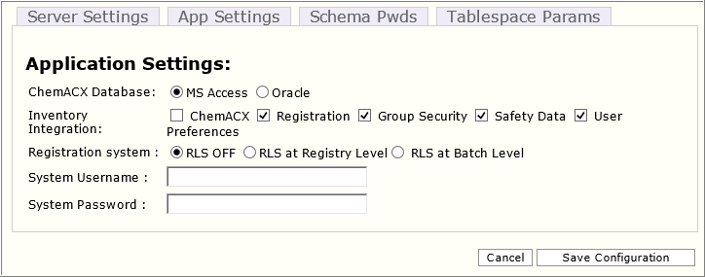

***Note****: If the database was upgraded from Oracle 11g to 12c, for working the RLS feature, you need to execute the following command as System:  
GRANT INHERIT PRIVILEGES ON USER SYSTEM TO REGDB;*

| **Fields** | **Description** |
| --- | --- |
| ChemACX Database | Select the oracle as the format for the ChemACX database. This setting affects the ChemACX and Inventory Manager Configuration files preparing them for ChemACX Oracle database connectivity. This step can be performed ahead of the actual database installation. It is not necessary that the database be copied or created ahead of this step.  The ChemACX application supports exporting the shopping cart contents to either MS Word or MS Excel documents. This functionality acts as simple integration point with procurement workflows that do not make use of more sophisticated electronic ordering systems. These export capabilities can be enabled via simple configuration ini settings, but also require some additional manual setup of the MS Office applications within the application server. |
| Inventory Integration | Enables the integration of the Inventory Manager application with other modules such as ChemACX, and Registration.  ChemACX Integration  The Inventory Manager optionally supports integration with the ChemACX procurement database. This integration allows the Inventory system to search the data in the ChemACX database. This integration can be enabled using the Configuration tool by checking the ChemACX box under the Inventory integration section. This option should not be enabled if the ChemACX module has not been installed.  Each distribution of the ChemACX database includes a SQL script that updates the Inventory Manager database with new vendor and package size information added to the ChemACX database. The following process should be followed to synchronize the Inventory database for use with ChemACX:   1. Insert the latest ChemACX database distribution CD. 2. Extract Oracle database distribution package by executing the appropriate self-extracting executable 3. Run the batch file update_inventory_for_chemacx.cmd   Registration Integration  The Inventory Manager optionally supports integration with PerkinElmer’s Registration Enterprise system. This is a by-directional integration where the Inventory System can search and display registered compounds and the Registration system can create Inventory containers to track registered substances.  User Preferences  Select this option to display the User Preference details. This feature works only if the CBOE-ELN integration feature is configured. Once the CBOE-ELN integration feature is configured and the User preferences check-box is selected, the user details saved in E-Notebook is displayed in CBOE application and vice-versa.  ***Note****: This feature works only if the CBOE-ELN integration feature is configured.* |
| Enable Row Level Security | The Registration system can be optionally configured to implement project based virtual databases. This option is referred to as “Row Level Security” because it prevents certain users from accessing individual database rows based on their security clearance. Row level security is applied based on associations between users, projects, and registered compounds. A user will only see those registered compounds that are associated with projects to which he or she has been granted permissions. The Row Level security feature can be enabled/disabled using the configuration tool dialog. For more details about the Row Level Security feature please refer to the Registration System Admin Guide.  ***Note****: To make use of RLS feature, you need to have a valid Oracle Enterprise license. RLS feature will not work with Oracle Standard.* |

### Schema Passwords

Most of the connections between the applications and the database are established using the credentials provided by the end-user during login. However, the application modules must sometimes connect to the database using the credentials of the schema owner. The system and schema passwords are stored on in the cfserver.ini files on the server. The password can optionally be encrypted for additional security.

This section of the configuration tool collects the schema passwords to be written to the cfserver.ini files. Note that the tool does not set or change the schema password in Oracle database. It simply writes the provided password to the appropriate ini files. The tool does, however, verify that the provided passwords are valid before proceeding. It is therefore required that target schemas exist and that their password be known ahead of using this tool to set the ini files.

Typically the configuration tool is first executed prior to the existence of the database schemas. It is therefore expected that this section of the tool will not be used until the initial configuration settings have been applied and the database scripts created. This section should be used to update the passwords in the ini configuration files if they were changed from their default values either during initial schema creation or at a later time. Validation of the schema passwords will fail if changes are made in this section prior to the existence of the schemas.

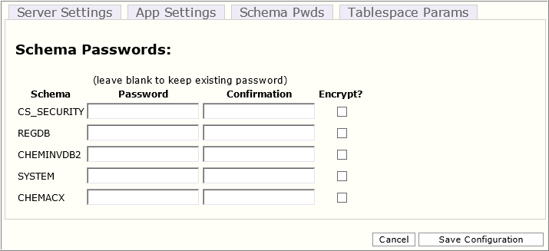

The default schema password for all ChemOffice WebServer databases is “ORACLE”. The default password for the system account is “manager2”. If the default values were used during the database schema creation then it will not be necessary to reset any of the ini files. In this case, this section can be left blank. If a password has been modified, then enter the new password into the corresponding Password and Confirmation text boxes. To encrypt the new password, select the Encrypt? Check-box.

To decrypt an existing password, enter the password in the corresponding Password and Confirmation text boxes and deselect the Encrypt? Check-box.

### Tablespace Parameters

The Oracle sql scripts used to create the application database schemas contain parameters that determine the size and file system path of tablespace data files. This section of the configuration allows modification of some of the entries in parameter.sql files. While each application schema has its own parameterized default paths, the configuration tool allows for only one default path per file-type to be set. For example, the entry under Table Data will be applied as the default table data file path for all application schemas. The values displayed in this section at start up are read from the first schema that uses this setting. Clicking the thumb icon under the “check” column will show the paths currently set for all other schemas that use the settings. A green “thumbs-up” icon indicates that all schemas that used the setting are currently set to use the same path. A red “thumbs-down” icon indicates that some paths may have been manually edited outside of this tool and are therefore not consistent with the setting about to be applied. This is mean to be a warning to the user that manually modified parameter entries will be modified when the new settings are saved.

The table on the bottom half of this section allows viewing and setting the data file size for all tablespaces. The sizes can be expressed in Kb, Mb, or Gb by using K, M, or G suffixes.

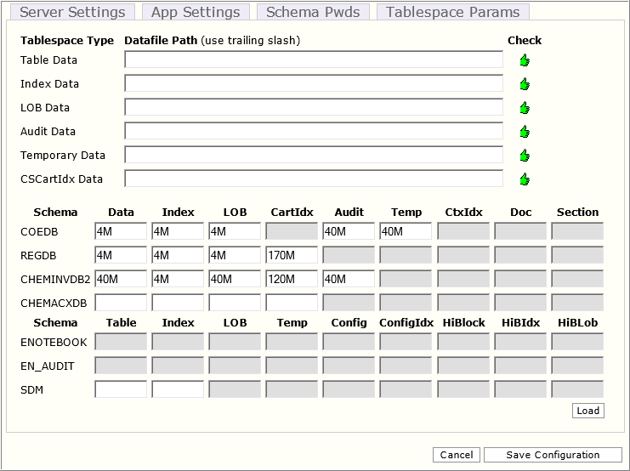

### Loading Tablespace Parameters from ini file

The decisions regarding tablespace path and size require significant planning and cooperation between PerkinElmer service engineers and the customer DBA. The decisions of specific file paths and individual data file sizes must be reached well before the configuration tool is used. To simply the process of gathering and applying this complex tablespace parameter information, the configuration tool supports “loading” an initialization file instead of having to type the desired configuration values. All the entries presented in the “Tablespace Parameters” section of the configuration tool are also available in a simple text ini file named “CBOETableSpaceParameters.ini”. This file can be reviewed and populated ahead of time and its information loaded into this section of the configuration tool using the “Load” button. Entries loaded from the .ini file will appear in blue colored font until they are saved to the server.

The .ini file contains separate entries for the default path of each type of tablespace file:

* defaultTableTSPath: The path to the tablespace files.
* defaultIndexTSPath: The path to the index tablespace files.
* defaultLobTSPath: The path to the lob tablespace files.
* defaultAuditTSPath: The path to the audit tablespace files.
* defaultcscartTSPath: The path to the chemical index (cscartridge) tablespace files.
* defaultTempTSPath: The path to the temporary tablespace files.
* defaultSecurityTSPath: The path to the security tablespace files.
* defaultctxTSPath: The path to the ctx (Oracle Text index) tablespace files.
* defaultdocTSPath: The path to the tablespace used to store document BLOBs

In order to modify the destination path of the tablespaces created, follow the steps below:

1. Open the *CBOETableSpaceParameters.ini* file and go to [DEFAULT_TSPATHS] section
2. Enter the desired path for each tablespace file in between the single quotes
3. All paths must end with a slash and the path must be valid.

***Note:*** *The above example would be valid for a Windows based Oracle host. For a Unix based Oracle installation a valid Unix path should be provided (Ex. ‘space01/oradata/orcl/’). In either case, the path should contain the trailing slash.*

*If TSPath entries are left unedited, then the tablespaces will be created in the location of the System tablespace data file.*

The CBOETableSpaceParameters.ini files also control the initial size of each of the tablespace files. By default, the sizes are appropriate for a small test installation. It is therefore required that for production installations the settings be modify to set tablespace sizes that are commensurate with the expected size and growth pattern of the database.

To change tablespaces sizes, open the *CBOETableSpaceParameters.ini* file, locate the bracketed section associated with the desired schema, and enter the tablespace sizes using K, M, or G to designate Kb, Mb, or Gb.

The estimated file size should be based on the number of records that are expected for the given application module multiplied by the average expected record size. These two factors vary drastically depending on the application module and the data storage needs of each customer. Typically, the record size is driven by the size and number of chemical structures associated with each record and/or by the size of other large documents stored in the database. Another factor that can drastically affect the size of the tablespace files is the chosen database block size.

Given the complexity and unpredictability of the factors involved in the size calculation, an empirical, rather than predictive approach is recommended. An initial (rough) guess of the file size should be used during the setup of the test environment. After all legacy data has been loaded, an analysis can be performed of the resulting data file sizes. The sizes of the test system tablespace files can then be used as a starting point to estimate the production system file sizes by taking into account the expected growth patterns.

***Note****: All tablespaces are created with autoextend enabled. Not setting the "autoextend on" option places a responsibility on the DBA to ensure that there is always room within a data file for object (table and index) growth.*

## Additional Configuration

This section details additional optional configuration and installation steps which are not automatically handled by either the installer or the configuration tools.

### Inventory Manager

Install T-Barcode ActiveX Component

A third party ActiveX control is required for Inventory reports that include barcodes. The T-Barcode ActiveX installer is delivered to the server during the installation of the Inventory module and can be found at the following location:

*<webroot>\ChemOffice\ChemInv\Installation\Tbarcode\TBarCode_x64_Setup.exe*

To install T-Barcode:

* Launch *TBarCode_x64_Setup.exe*
* Click Yes to install.
* Click Yes in the license agreement window.
* Browse to the destination folder and click Next.
* Click OK.

Location Based Security (Optional)

The Inventory Manager optionally supports the use of Oracle Row Level Security to prevent users or groups from accessing protected inventory locations. This feature is enabled by executing a database script that defines the Oracle Fine Grained Access Control policies. A hyperlink to execute this database script can be found in the Database Creation Guide. Further details on executing the database script to enable location based security are provided in the Database Creation section below.

Integration with Registration Enterprise (Optional)

The Inventory Manager optionally supports integration with PerkinElmer’s Registration Enterprise system. This is a by-directional integration where the Inventory System can search and display registered compounds and the Registration system can create Inventory containers to track registered substances. The steps required to enable this integration are:

* Set the REG_SERVER_NAME entry in the <webRoot>\ChemOffice\ChemInv\config\invconfig.ini file to the fully qualified name of the HTTP server hosting the Registration module. (Note: This task is automatically performed by the Configuration Tool if the Registration integration box is checked)
* Set the data source in the <webRoot>\ChemOffice\ChemInv\config\chemreg.udl to the name of the Oracle service name where the Registration data is hosted.

**Note:** *This task is automatically performed by the Configuration Tool based on the Service Name value provided*

The Inventory Manager accesses the Compound and Batch data stored in the Registration System via a set of Oracle views created in the Inventory database schema. A SQL script is provided to create the views. The views can be modified under the direction of PerkinElmer Service Engineers to expose registration data from other sources. Details on executing the script that create the Registration integration views are provided in the Database Creation section below.

Installing InvLoder (Optional)

The Inventory Manager includes InvLoader, an optional stand-alone application that can be used for bulk loading containers and plates into the Inventory database.

The InvLoader installer is delivered to the server during the installation of the Inventory module and can be found at the following location:

*<webroot>\ChemOffice\ChemInv\Installation\InvLoader\InvLoaderSetup.exe*

To install InvLoader:

1. Navigate to the above path and launch the installer.
2. Choose the destination folder for the application files.
3. Choose the Start Menu location where the installer will create a **shortcut** to the InvLoader application.
4. Choose whether the installer should create a **desktop icon** to the application.
5. Review the installation settings and click Install
6. Click **Finish**.

Disabling Plate Features (Optional)

The Inventory Manager optionally supports plate handling features which allow tracking inventoried compounds in plates and racks, rather than in independent containers. Refer to the Inventory Manager Users’ Guide for details. The plate features are enabled by default, but can be disabled by setting the ENABLE_PLATE_MANAGEMENT entry in the *<webRoot>\ChemOffice\ChemInv\config\invconfig.ini* to “False”.

IIS needs to be restarted before the configuration changes take effect.

Zebra Label Printing

To enable users to print labels, the LPR definition and label printer itself must be configured. For information see the Inventory Enterprise User Guide and Administrator Guide.

### ChemACX Oracle

MS Office Integration

The ChemACX application supports exporting the shopping cart contents to either MS Word or MS Excel documents. This functionality acts as simple integration point with procurement workflows that do not make use of more sophisticated electronic ordering systems. These export capabilities can be enabled via configuration ini settings, but also require some additional setup of the MS Office applications within the application server.

Additional Configuration

Additional optional features of the ChemACX application can be enabled by setting entries in either the cfserver.ini or the acxconfig.ini files. Changes to those files should be performed under the direction of PerkinElmer support personnel.

### Registration Enterprise

Enable Row Level Security

The Registration system can be optionally configured to implement project based virtual databases. This option is referred to as “Row Level Security” because it prevents certain users from accessing individual database rows based on their security clearance. Row level security is applied based on associations between users, projects, and registered compounds. A user will only see those registered compounds that are associated with projects to which he or she has been granted permissions. The Row Level security feature can be initially enabled during the Registration system database setup by answering the appropriate prompt. It can later me enabled/disabled using the Registration system’s configuration dialog. For details, refer to the Registration System Admin Guide.

ChemScript Integration

The Registration system can be optionally configured to integrate with ChemScript. ChemScript is used to normalize chemical structures submitted to the temporary table. These types of chemical modifications are accomplished via PerkinElmer’s ChemScript, which extends the standard Python scripting environment with chemically intelligent functions. All the components required for integration between ChemScript and Registration, including ChemScript, Python, and PyEngine are installed and configured by the server installer. Enabling/disabling the structure normalization features is controlled from the Registration system’s configuration dialog. For details consult the Registration System Admin Guide.

## Configuration Changes for Web Registration (Optional)

### Setting up Maximum Worker Processes

You need to configure the *Maximum Worker Processes* of Registration.Server in the IIS to match with the CPU count.

**To configure Maximum Worker Processes for Registration.Server**

1. To access the *Internet Information Services (IIS) Manager* console, do the following.

* On the desktop, hover the mouse cursor in the upper-right corner of the screen, and then click **Search**.
* In the Search box, type **inetmgr** and press ***<Enter>****.*

1. In the IIS Manager, expand the local computer and click **Application Pools**.
2. Right-click **Web Registration** and click **Advanced Settings**.
3. In the *Advanced Settings* window, configure the **Maximum Worker Count** to match with the CPU count of the machine.

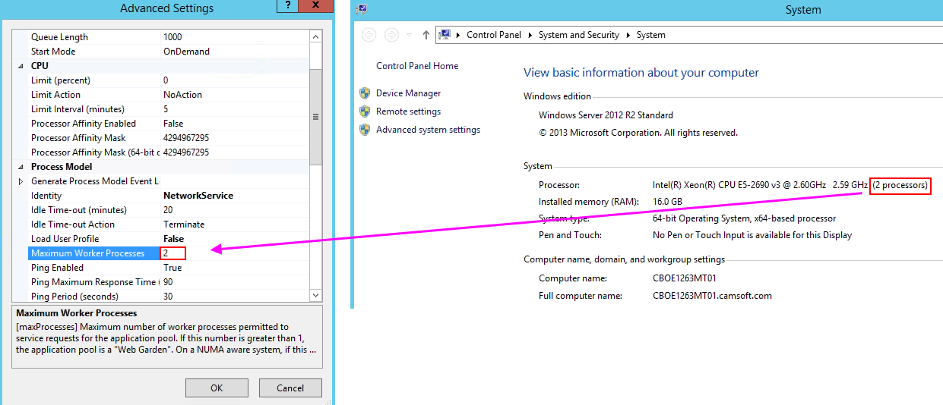

1. Click **OK**. Make sure that your changes are saved.

### Updating Web.Config File

You need to manually update the domain name in the CDJS URL in the web.config file of Registration.server as described below.

1. Navigate to *C:\Program Files (x86)\PerkinElmer\ChemOfficeEnterprise\Registration.Server*.
2. Open the file **Web.config** for edit.
3. In the CDJSUrl tag, enter the fully qualified server name as entered in the server configuration tool.

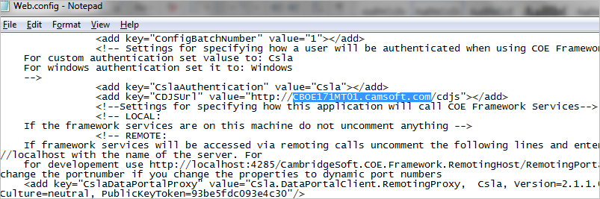

1. Save and close the file.
2. Importing Application Configuration

## Importing Chemical Registration Configuration

To Import the Chemical Registration configuration, follow the steps below:

| **Step** | **User Input/Action** | **Expected Results** |
| --- | --- | --- |
| 1 | Type the following address in the address bar of your Web browser:  *http:// YourHttpHostName/COEManager* |  |
| 2 | The ChemBioOffice Enterprise User Login page appears |  |
| 3 | Log into the ChemBioOffice WebServer using the following username and password: T5_85/T5_85 |  |
| 4 | From the main menu, click the Customize Registration button |  |
| 5 | The Registration Admin page is opened:    Click the **Import / Export Configuration** link. |  |
| 6 | In the *Import from server side local directory* section, enter the server path (typical location is: …*.\PerkinElmer\ChemOfficeEnterprise\Registration\Config*).    Select the “Force Import” checkbox to replace the existing configuration with the configuration from the configuration files imported.  Click **Import**. | A new message will appear when the import is completed. |
| 7 | Logout from ChemBioOffice. |  |
| 8 | After importing the configuration, it is now possible to create views for integration with Registration.  To do that go to **Start > ChemBioOffice Enterprise > Database Creation Scripts** and then click on the "click here" link corresponding the "Create views for integration with Registration" option. |  |
| 9 | Enter the target Oracle service name:  Enter the name of the target Oracle service.  This is the same name that should have been tested in section TNS Names Configuration. |  |
| 10 | Enter the name of an Oracle account with system privileges (system): If your oracle account with system privileges is system, click Enter. For another one, enter the name of the oracle account. |  |
| 11 | Enter the above oracle account password (manager2): If system password has been temporarily changed to “manager2”, click Enter. Otherwise, enter the system password. |  |
| 12 | Run Server Configuration Tool with preferred settings. Refer to section 8.3. Configuration Tool |  |

## Updating invconfig.ini file for non C-Drive Installation

If you are installing CBOE 19.1 on a drive other than C drive, you must update the REPORT_DB_PATH in the *invconfig.ini* file.

**Updating the *invconfig.ini* file**

1. Open *<webroot>\ChemOffice\ChemInv\config\invconfig.ini* file.
2. Go to [REPORTS] section.
3. Make sure that the *REPORT_DB_PATH* path is correct as shown in the image.

***Note****: Even if you install CBOE on a drive other than C-drive, the mdb files are saved in C drive (C:\ChemOffice_Data\cheminv)*

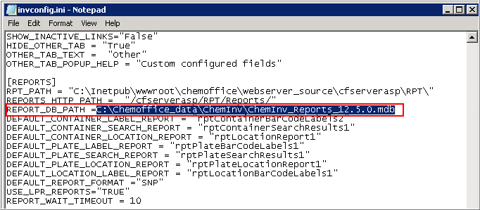

1. Save and close the file.

## Configuration Settings for Inventory Reporting

### Installing Tbarcode

***Note****: If you upgrade your CBOE application, you may need to first uninstall the old Tbarcode, and then follow the steps mentioned below to install the new 64-bit Tbarcode.*

To install the new 64-bit Tbarcode, follow the steps:

| **Step** | **User Input/ Action** | **Expected Results** |
| --- | --- | --- |
| 1 | Go to *<webroot>\ChemOffice\ChemInv\Installation\Tbarcode\.* |  |
| 2 | Double-click *TBarCode_x64_Setup.msi*. | Welcome dialog box appears. |
| 3 | Click **Next**. | End-user license agreement dialog box appears. |
| 4 | Read the license agreement and select “*I accept the terms in the License Agreement”.*    Click **Next**. | Custom Setup dialog box appears. |
| 5 | Select the features you want to install and click **Next**. | Ready to Install dialog box appears. |
| 6. | Click **Install**. | Get Free Support dialog box appears. |
| 7. | Click **Next**. |  |
| 8. | Click **Finish**. |  |

### Inventory Reporting Prerequisites

The following prerequisites must be satisfied for the proper functioning of the Inventory reporting service.

1. Tbarcode needs to be installed.
2. WIN2PDF needs to be installed and it should be configured as the default printer.

***Note****: If Tbarcode is not installed, it can be installed from <webroot>\ChemOffice\ChemInv\Installation\Tbarcode*

*Also, if Win2PDF is not installed, it can be installed from <webroot>\ChemOffice\ChemInv\Installation\win2pdf.*

*It is important to make sure that Win2PDF is the default printer on the server machine.*

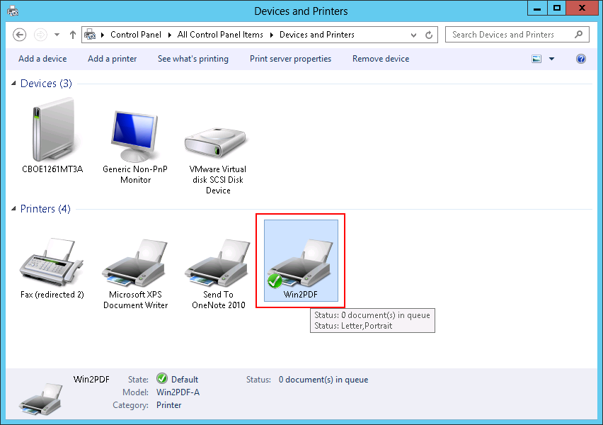

1. In the MS Access application, the following configurations need to be performed:

* Macro level should be set to "*Enable All Macros*"
* ActiveX settings should be configured as *“Enable all controls without restrictions and without prompting*”.

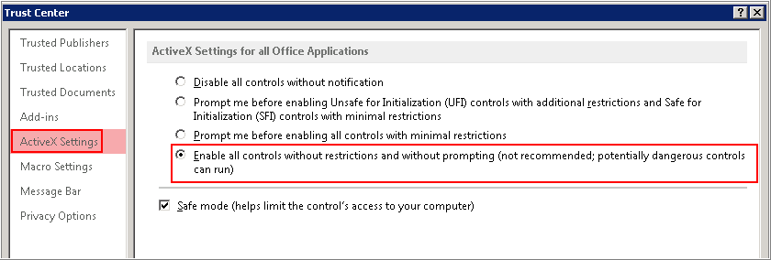

1. On your Web browser, the following configurations need to be performed.

* Open your Web browser, and add the CBOE url to the trusted sites.
* Set the Security level slider to the lowest.

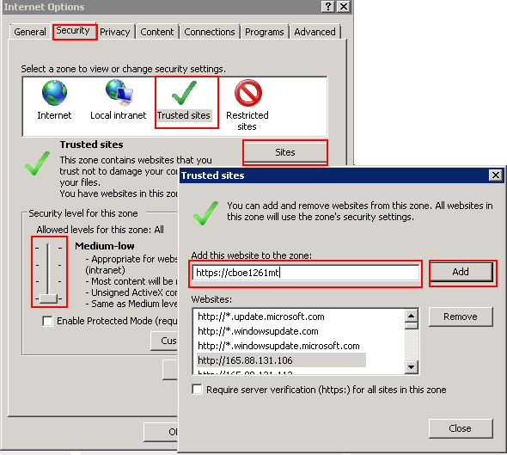

### Configuration Settings

To generate Inventory reports using “Inventory Reporting service (RPTService)”, you need to do following configuration.

**To configure RPTService settings:**

1. Go to Start > Run.
2. Type *services.msc*, and press <Enter>.
3. In the Services window, select RPTService.
4. Right-click RPTService, and click Properties.

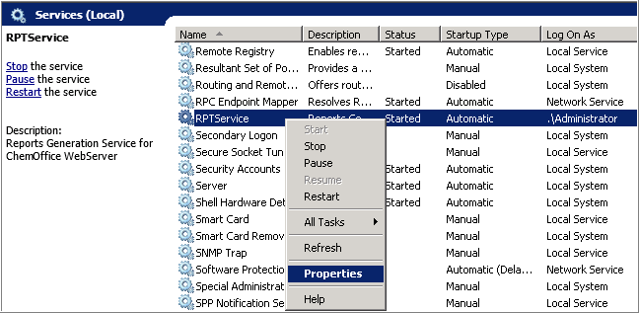

1. In the RPTService Properties window, click **Log On** tab.
2. Make sure that the RPTService is running as the logged in user. If you have logged in as administrator, then the RPTService needs to be run as administrator as shown in the image.

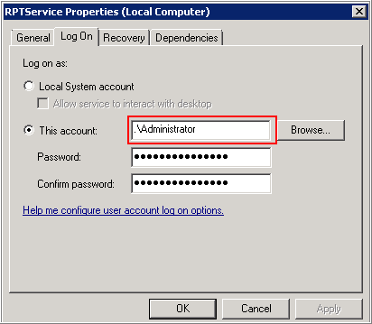

1. Click **OK**.

**To configure REPORTQ COM+ settings**

1. Go to **Start > Administrative Tools > Component Services** and press **Enter**.
2. Navigate to **Component Services > Computers > My Computer > COM+ Applications > REPORTQ**.

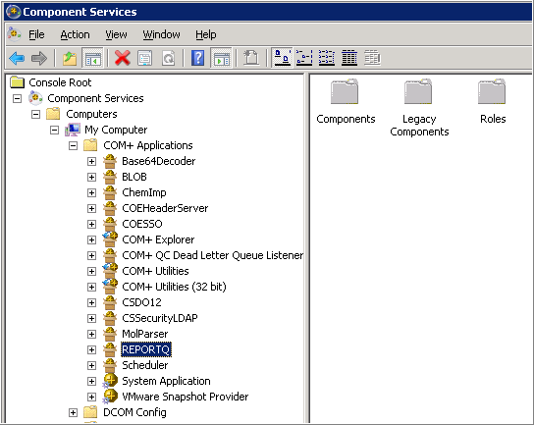

1. Right-click REPORTQ, and click **Properties**.
2. In the Properties window, click **Identity** tab.
3. Make sure that REPORTQ COM+ is running as the logged in user. If you have logged in as administrator, then the RPTService needs to be run as administrator as shown in the image.

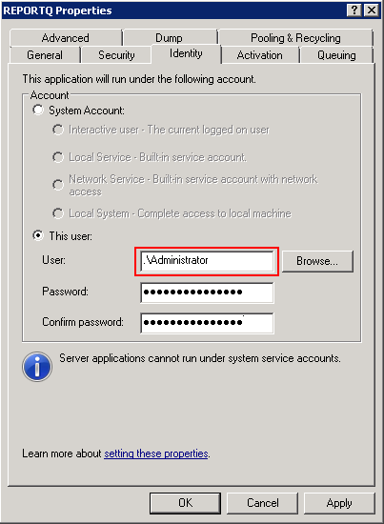

1. Click **OK**.

### Enable Directory Browsing

Directory Browsing should be enable for the following components

* CFServerASP
* CFServerADSI
* CFServerAdmin
* CFWTemp
* ChemINV

To enable the Directory Browsing:

1. Go to **Start > Administrative Tools > Internet Information Services Manager**
2. Expand the **local Server > Sites > Default Web Site.**
3. Select **CFServerAdmin** and double-click **Directory Browsing**.

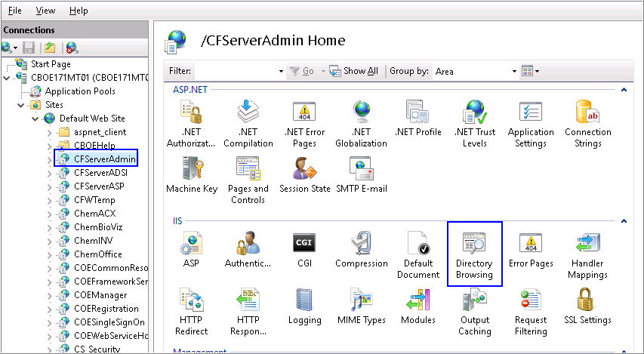

1. Select **Enable** from the right pane.

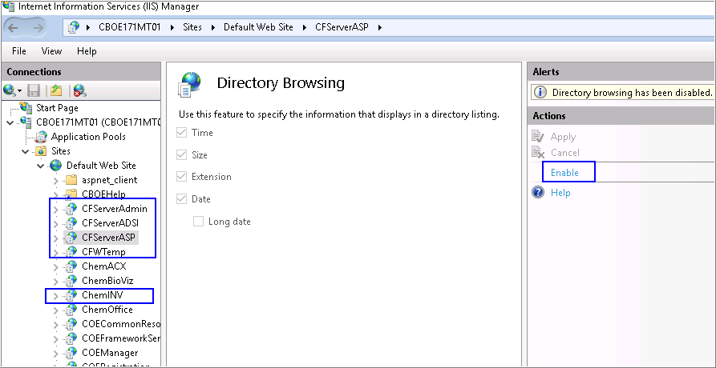

1. Repeat **Step 3** and **Step 4** for the other components such as **CFServerASP, CFServerADSI, CFWTemp,** and **ChemINV.**

### Installing CDAX 18.1 NA on Server

For the proper functioning of Inventory reporting, CDAX 18.1 NA should be installed on the Server machine. You may refer to the section 10.1.3 Installing CDAX 18.1 more details

1. Client Workstation Installation

***Note****: To use Web Registration in Microsoft Internet Explorer 11 with ChemDraw JS, make sure that you have installed* ***Java Runtime Environment******1.8*** *or later in the client machine.*

## Installing ChemDraw ActiveX (CDAX) Enterprise Constant NA 18.1

ChemDraw ActiveX 18.1 Plugin can be downloaded from the ChemBioOffice Enterprise home page.

### Installation Prerequisites – Installing Microsoft Visual C++ 2017 Runtime Libraries

As a pre-requisite, you need to install Microsoft visual C++ 2017 runtime libraries as shown below.

1. Browse to *Distribution Package\Installer\Dependencies\Microsoft Visual C++ 2017 Redistributable(x86)*
2. Double-click **vcredist_x86.exe**.

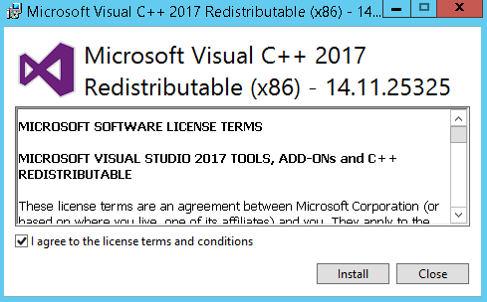

1. Read and accept the license agreement, and click **Install**.

### Installation Prerequisites – Enabling .NET Framework 3.5 in Windows 8.1 (Optional)

***Note****: If any previous version of CDAX is currently installed on your machine, you may need to uninstall the current version of CDAX before installing CDAX 18.1.*

**Enabling .NET Framework 3.5 in Windows 8.1 (Optional)**

If you use Windows 8.1 client, you may need to enable .NET Framework 3.5 in the Control Panel for the proper functioning of CDAX 18.1.

**To enable .NET Framework 3.5 in Windows 8.1:**

1. Move the mouse pointer to the upper- right corner or lower-right corner of the screen, and click the **Settings** icon from the Charms bar that appears.
2. Click **Control Panel**.
3. Click **Programs > Turn Windows features on or off**.
4. Select the **.NET Framework 3.5 (includes .NET 2.0 and 3.0)** check box.

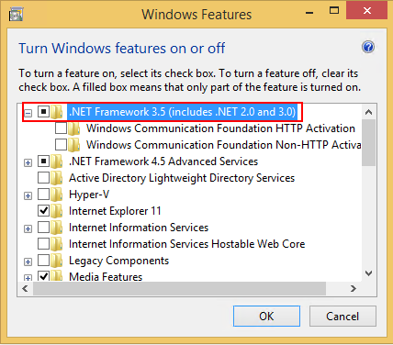

1. Click **OK**.

### Installing CDAX 18.1

To install ChemDraw ActiveX 18.1 Plugin, please follow these steps:

| **Step** | **User Input/ Action** | **Expected Results** |
| --- | --- | --- |
| 1 | Open your Web browser, and enter the following URL:  *https://servername/COEManager*  *<servername>* is the name of the server where ChemBioOffice Enterprise is installed. | The User Login page of ChemBioOffice Enterprise appears. |
| 2 | Enter a valid username and password. |  |
| 3 | Click the Log in button to display the home page of ChemBioOffice Enterprise. |  |
| 4 | Click on **CDAX18.1 Plugin** icon under "Applications & Utilities" section.    Click **Run** to download the installer. |  |
| 5 | The following window appears, click **Next.** | License Agreement window appears. |
| 6. | Read the license agreement and if you agree to the license agreement, select **I accept the terms in the license agreement**.    Click **Next**. | Destination Folder window appears. |
| 7. | To install in a different folder, other than the default folder, click **Change** and select a new destination folder.    Click **Next**. | Ready to Install the Program window appears |
| 8. | Click **Install** to initiate the installation. |  |
| 9. | Click **Finish** to complete the installation. | InstallShield wizard closes. |

## InvLoader Installation

To install InvLoader on your client machine, perform the steps below:

***Note****: It is recommended to use InvLoader from the application server instead of client machine.*

| **Step** | **User Input/ Action** | **Expected Results** |
| --- | --- | --- |
| 1 | Logon to the CBOE web server and copy the InvLoader folder from the following directory:  C:\inetpub\wwwroot\ChemOffice\ChemInv\Installation\InvLoader. | Logon successful |
| 2 | Paste the folder copied in step 1, anywhere on your client machine and browse to the “InvLoaderSetup.exe” file. | File found |
| 3 | Initiate the installation by double clicking on the “InvLoaderSetup.exe” file.    Click **Next**. | Windows installer initiates the installation from the setup program. Destination Location selection window appears. |
| 4 | The default destination folder is displayed. To install in a different location, click Browse and select a new location.    Click **Next**. | Start Menu Folder selection window appears |
| 5 | Click **Next**. | Additional Tasks selection window appears. |
| 6 | Select the check box to ceate a desktop icon.    Click **Next**. | Ready to Install window appears. |
| 7 | Click **Install** to start the installation. |  |
| 8 | Click **Finish** when the installation is done. |  |

***Note****: For the proper functioning of InvLoader and Inventory Reports applications, ensure that you have installed the same version of MS Office on both CBOE Server and Client.*

1. Upgrading CBOE 12.1.3, 12.6.3 PF1, CBOE 17.1 CBOE 17.1.1, CBOE 18.1, and CBOE 18.1.1 to CBOE 19.1

CBOE 19.1 installer is designed for upgrading your old version of CBOE (CBOE 12.1.3, CBOE12.6.3 PF1, CBOE17.1, CBOE 17.1.1, CBOE 18.1, and CBOE 18.1.1) to the most recent version, CBOE 19.1. To upgrade CBOE 12.1.3, and CBOE 12.6.3 PF1 to CBOE 19.1, you need to first uninstall the old version of CBOE from the machine. After you complete uninstalling your old version of CBOE, the process and procedure for upgrading CBOE is same as that of installing CBOE fresh on a machine. To upgrade CBOE 17.1/17.1.1/18.1/18.1.1 to CBOE 19.1, you need not uninstall the current version of CBOE from the machine.

## Uninstalling the Old Version of CBOE (Only for CBOE 12.1.3/12.6.3 PF1 to CBOE 19.1 Upgrade)

***Note 1****: This is not required if you upgrade from CBOE 17.1, CBOE 17.1.1, CBOE 18.1, or CBOE 18.1.1 to CBOE 19.1.*

As a first step to upgrade your CBOE, you need to uninstall the old version of CBOE and its add-in components, if any, from the machine.

***Note 2****: Stop the* ***RPTService*** *service before proceeding with the 12.6.3 uninstallation.*

***Note 3****: Uninstalling the previous version of CBOE removes all files and folders from the install locations. Hence, it is recommended to take a backup of the necessary files, as required.*

***Note 4****: If you have created any customized reports before you perform an upgrade, you need to perform the following steps to make the customized reports available in the upgraded system.*

1. *Before you perform an upgrade, take a backup of the existing .mdb file from the location C:\ChemOffice_Data\ChemInv*
2. *After you perform the upgrade, open the new access file and click on* ***File > Get External Data > Import*** *and browse to the backup .mdb file and import any custom reports/queries. This will import the custom report\queries to the new .mdb file.*

Follow the steps below to uninstall the old version of CBOE from the machine.

1. Go to **Control Panel** **> Programs > Uninstall a program**.
2. Select **ChemBioOffice Enterprise 12.6.3** and click **Uninstall**.

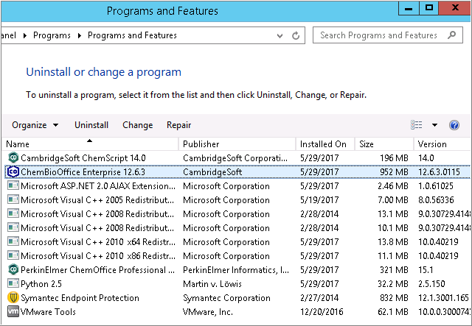

***Note 1****: After uninstalling CBOE 12.1.3/12.6.3, you need to manually delete the folder “ChemOfficeEnterprise12.1.0.0”, if it exists, from the following locations:*

* *<Installation Directory>\Program Files (x86)\CambridgeSoft*
* *C:\ProgramData\CambridgeSoft*
* *C:\inetpub\wwwroot\ChemOffice*
* *C:\ChemOffice_Data*

***Note 2****: You need to uninstall all the previous versions of CBOE. For example, if the installed CBOE 12.6.3 is an upgrade installation, you need to uninstall CBOE 12.6.3 along with all the previous versions of CBOE.*

## Upgrading ChemBioOffice Enterprise Server

After you complete uninstalling your old version of CBOE, the process and procedure for upgrading CBOE is same as that of installing CBOE fresh on a machine. Refer to section 6.5 Installing ChemBioOffice Enterprise 19.1 for detailed description on installing CBOE 19.1.

## Activate ChemDraw and ChemScript

Refer to section 6.7 Activate ChemDraw Professional and section 6.8 Activate ChemScript for detailed description on activating ChemDraw and ChemScript.

## Upgrading CBOE Database Schemas

The ChemBioOffice Enterprise 19.1 Database Upgrade Guide provides hyperlinks to launch each of the database update scripts.

To launch the Database Upgrade Guide: go to **Start > ChemBioOffice Enterprise > Database Upgrade Scripts**. The following page appears:

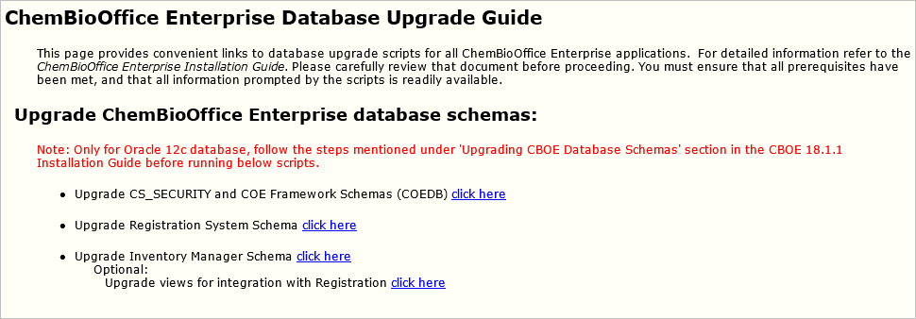

Click each of the links to update the corresponding database. The COE Framework Schema script is the only one required for all installations. The other upgrade scripts should be executed (in the order in which they appear on the page) if the corresponding application module was previously installed. Clicking a hyperlink to launch a script for an application that has not been installed will result in an error.

While executing the scripts, you may get the following ignorable errors. It is absolutely safe to ignore the errors.

* PLS-00302: component must be declared
* ORA-00955: name is already used by an existing object
* ORA-12003: materialized view or zonemap does not exist
* ORA-00942: table or view does not exist
* ORA-00001: unique constraint violated
* ORA-12002: there is no materialized view log on table
* ORA-01418: specified index does not exist

### Updating Customized CBOE Schema Passwords

If the customer has set password for COEDB/REGDB/CHEMINVDB2 other than the default password "oracle", you need to perform the steps mentioned below before you start upgrading your CBOE.

1. Open Server Configuration Tool.
2. Click the **Schema Pwds** tab and add customized passwords of CS_SECURITY, REGDB and CHEMINVDB2
3. Save the configuration.
4. Open the *parameters.sql* files available in the following locations and update the mentioned passwords manually:

* *<InstallationDirectory>\inetpub\wwwroot\ChemOffice\ChemInv\config\oracle_install_scripts\Create_blank_ChemInv_DB\sql*
  + DEFINE schemaName = CHEMINVDB2
  + DEFINE schemaPass = "Custom Password"
  + DEFINE securitySchemaName = COEDB
  + DEFINE securitySchemaPass = "Custom Password"
  + DEFINE regSchemaName = REGDB
  + DEFINE regSchemaPass = "Custom Password"
* *<Installation Directory>\Program Files (x86)\PerkinElmer\ChemOfficeEnterprise\Framework\DBInstallScripts\COEDB\Oracle_Install_Scripts\sql*
  + DEFINE schemaName = COEDB
  + DEFINE schemaPass = "Custom Password"
  + DEFINE securitySchemaName = COEDB
  + DEFINE securitySchemaNameOld = CS_SECURITY --Temporary
  + DEFINE securitySchemaPass = "Custom Password"

### Steps to be done in Oracle 12c Upgrade Environment

1. Before upgrading the COEDB schema through DB upgrade scripts, open a separate command prompt and login to sqlplus as SYS user:  
   e.g.  
   Enter user-name: sys@<oracle service Id> as sysdba  
   Enter password: <password for SYS user>
2. Once connected successfully, execute: alter system set "_projection_pushdown" = false scope=both;
3. Execute: grant select on sys.user$ to COEDB;
4. Now upgrade the COEDB schema and rest of the schemas through DB upgrade scripts.

### COE Framework Schema

To upgrade the CS_SECURITY and COE Framework schemas, follow the steps below:

1. Click the *click here* link corresponding to *Upgrade CS_SECURITY and COE Framework Schemas (COEDB).*
2. In the command window, enter the following details when prompted.

* Target Oracle service name:
* Name of the Oracle account with system privileges:
* Oracle account password:
* Which version do you want to upgrade to:

***Note****: 19.1 is the default value. You may press <Enter> to accept the default value.*

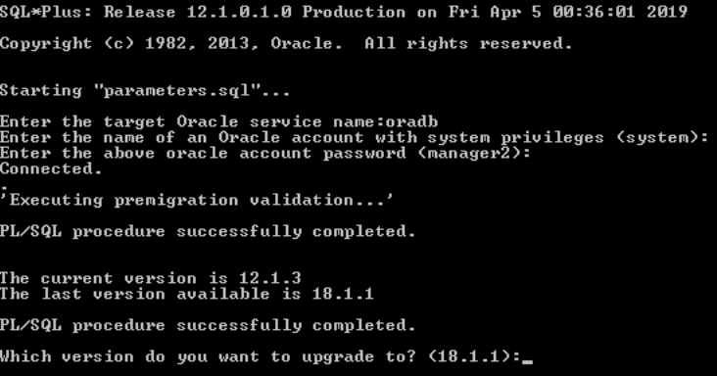

After the execution of this script, the summary log appears. Be sure Errors is equal to zero. If not, open and inspect the following log file *COEDB_LOG_PATCHES_COEDB_ORA.TXT* using the shortcut at Start > ChemBioOffice Enterprise > Setup Logs.

### Registration System Schema

To upgrade the Registration system schema, follow the steps below:

1. Click the *click here* link corresponding to *Upgrade Registration System Schema.*
2. In the command window, enter the following details when prompted.

* Target Oracle service name:
* Name of the Oracle account with system privileges:
* Oracle account password:
* Name of the target schema owner:
* Oracle account password:
* Which version do you want to upgrade to:

***Note****: 19.1 is the default value. You may press <Enter> to accept the default value.*

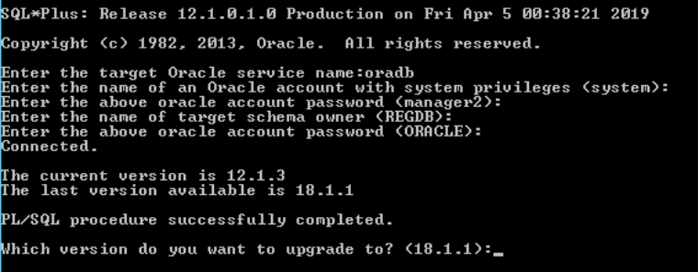

After the execution of this script, the summary log appears. Be sure Errors is equal to zero. If not, open and inspect the following log file *REGISTRATION_LOG_PATCHES_CHEMREG_ORA.TXT* using the shortcut at Start > ChemBioOffice Enterprise > Setup Logs.

### Inventory Manager Schema

***Note****: Before running the Inventory Manager schema, it is mandatory that you need to execute the Registration System schema to avoid any Oracle errors even though you are not using Registration.*

To upgrade the Inventory manager schema, follow the steps below:

1. Click the *click here* link corresponding to *Upgrade Inventory Manager Schema.*
2. In the command window, enter the following details when prompted.

* Target Oracle service name:
* Name of the Oracle account with system privileges:
* Oracle account password:
* Name of the target schema owner:
* Oracle account password:
* E-Notebook schema name:
* Which version do you want to upgrade to:

***Note****: 19.1 is the default value. You may press <Enter> to accept the default value.*

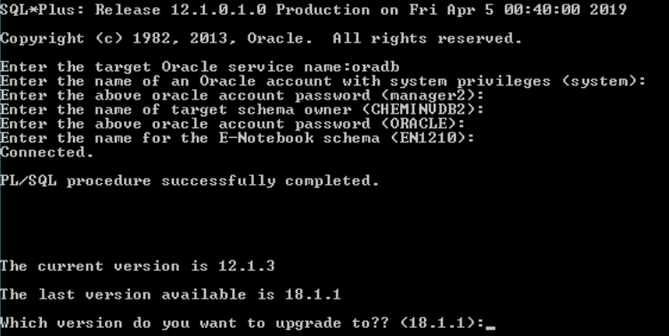

After the execution of this script, the summary log appears. Be sure Errors is equal to zero. If not, open and inspect the following log file *CHEMINV_LOG_PATCHES_CHEMINVDB2.TXT* using the shortcut at Start > ChemBioOffice Enterprise > Setup Logs.

### Importing Registration Configuration without Force Import (Only for CBOE 12.1.3 Upgrade)

After upgrading CBOE 12.1.3 to CBOE 19.1, you need to import the Registration configuration file without selecting the “*Force Import*” option as described below.

1. Log into the ChemBioOffice WebServer using the following username and password: T5_85/T5_85.
2. From the main menu, click the **Customize Registration** button.
3. Click the **Import / Export Configuration** link.
4. In the *Import from server side local directory* section, uncheck the **Force Import** check-box.

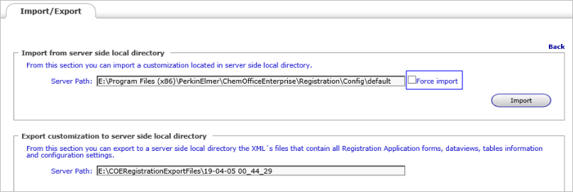

1. Click **Import**.

### Creating Views for Integration with Registration

To create Views for integration with Registration, follow the steps below:

| **Step** | **User Input/Action** | **Expected Results** |
| --- | --- | --- |
| 1 | Go to **Start > ChemBioOffice Enterprise > Database Update Scripts.**  **Click** the "click here" link corresponding the "Upgrade views for integration with Registration" option. |  |
| 2 | In the command window, enter the following details when prompted:   * Target Oracle service name: * Name of the Oracle account with system privileges: * Oracle account password: |  |

### COE Patching Tool

Follow the steps mentioned below to run the COE patching tool:

1. Navigate to *…..\PerkinElmer\ChemOfficeEnterprise\Framework\COEPatchingTool.*
2. Execute the *COEPatcher.exe* file.
3. Enter the following details when prompted:

* Oracle instance name:
* Oracle user:
* Oracle password:
* The version you are upgrading from:

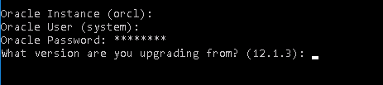

### Verification of Database Parameters

After executing the database update scripts, you need to verify that the parameters are correct as described below.

**To verify the parameters:**

1. Connect to the database, and execute the script *show parameter mv;*
2. Check whether it returns the values as shown below.

|  |
| --- |
| SQL> show parameter mv; |
| NAME                                 TYPE        VALUE |
| ------------------------------------ ----------- ------------------------------ |
| _mv_refresh_use_no_merge             **boolean**     FALSE |
| _mv_refresh_use_stats                **boolean**     TRUE |
| SQL> |

1. If the script does not return the values as shown, execute the following scripts to configure the values.

|  |
| --- |
| alter system set "_mv_refresh_use_no_merge" = **false** scope=both; |
| alter system set "_mv_refresh_use_stats" = **true** scope=both; |

## Running the Server Configuration Tool

You must run the server configuration tool after upgrading your current CBOE server to CBOE 19.1 and after running Database upgrade scripts. The configuration tool detects the installed application modules and edits their configuration files. It is therefore important that the tool be run only after all desired modules have been installed.

To launch the server configuration tool, go to **Start > All Programs > ChemBioOffice Enterprise > Server Configuration Tool**. Make necessary configuration changes in the required fields and save the changes.

Refer to section 8.3 Configuration Tool for detailed description and configuration of the server configuration tool.

## Upgrading Client

After you successfully upgrade your server and database, you need to upgrade your client by installing its latest version.

The steps for upgrading the client are the same as that of a fresh installation of the client applications mentioned in section 10 Client Workstation Installation.

* Refer to section 10.1 Installing ChemDraw ActiveX (CDAX) Enterprise Constant NA 18.1 to install CDAX 18.1
* Refer to section 10.2 InvLoader Installation to install InvLoader application

1. Troubleshooting

This section describes few issues/errors that you may encounter while installing CBOE 19.1 and the steps to resolve those issues. For more information on any issues/errors not discussed in this section, refer to the knowledgebase at: <http://www.cambridgesoft.com/support/EnterpriseSupport/KnowledgeBase/FAQ/>.

Select ‘**ChemBioOffice Enterprise**’ under Products and ‘**Installation**’ under Topics as shown below to list the installation related issues.

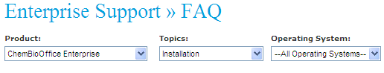

## ‘Could not load file or assembly Oracle.DataAccess’ Error

After successful installation of CBOE 19.1, you may encounter the following error when accessing COE Manager through Internet Explorer-

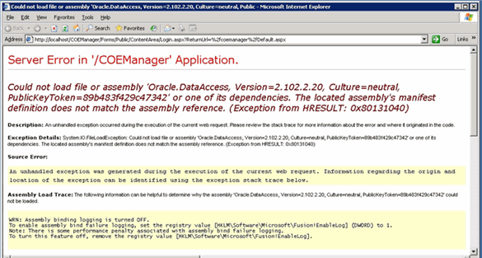

To resolve this error, ensure that the following is installed:

* Compatible version of Oracle Data Access Components (ODAC) which includes OLEDB Provider and Oracle Data Provider for .Net.

## Registering ASP.Net in IIS

If ASP.NET has not been registered to IIS, register it with the ASP.NET registration utility, which is located in the .NET Framework installation by executing the following command from the Windows command prompt:

<WindowsPath>\Microsoft.NET\Framework\v2.0.50727\aspnet_regiiis.exe -i

## .Net Framework Security

**Issue**: The following error appears while trying to search the TEMP area:

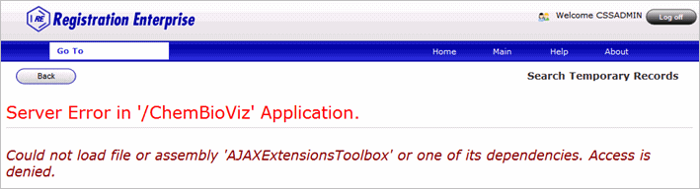

**Remedy:** The default access for the .NET framework folders should be updated manually, by giving the default Windows "Everyone" user group "Modify" privileges on the "C:\WINDOWS\Microsoft.NET\Framework" folder and all subfolders.

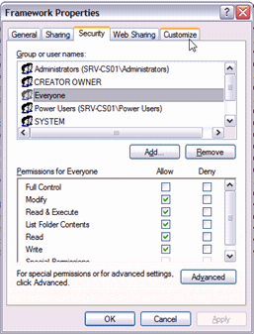

## Oracle 11g or 12c Related Issues

If CBOE is installed with Oracle 11g or 12c, then CBOE classical applications (Inventory, and ChemACX) should have the udl username/password in CAPITAL.

**Example:**

For Inventory:

* Go to C:\Inetpub\wwwroot\ChemOffice\ChemInv\config
* Double-click on ChemInv.udl and provide required details as
  + DataSource: orcl
  + Username: CHEMINVDB2
  + Password: ORACLE

Click on Test Connection button to verify. In order to make the password case-insensitive in Oracle 11g, please execute the query below:

alter system set sec_case_sensitive_logon=false;

## Error in RLS Log File 'log_runRLSConfigurationTool.txt

**Issue**:

You may receive errors in the RLS log file after performing the following steps:

1. Open the Server Configuration Tool.
2. Choose RLS at Registry level or Batch level.
3. Save the configuration.

After saving the server configuration settings successfully, verify the 'log_runRLSConfigurationTool.txt' file located at the setup log location. You may encounter errors in the log file.

**Remedy**:

You have to restart all the running oracle services in the DB server before running server configuration tool.

## Inventory Reporting Errors

If you encounter any difficulty in generating Inventory reports, perform the following checks:

1. Open the r*eportqueue.mdb* file from *<webroot>\ChemOffice\WebServer_Source\cfserverasp\RPT*.
2. Open the table tblReportQueue in the *reportqueue.mdb* file.
3. See the message in the ErrorMessage field to find the cause of report failed.

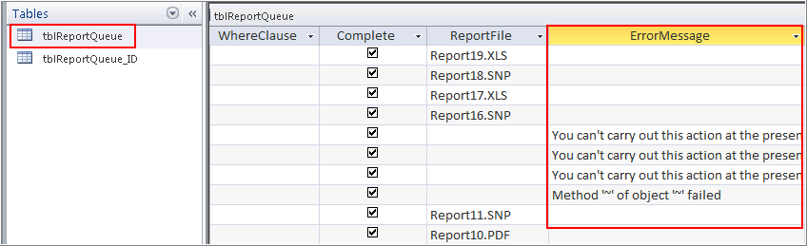

1. Open task manager and make sure that:

* Only one instance of *dllhost.exe* is running by the system user.
* Only one instance of *report.exe* is running.
* Only one instance of *msaccess* is running.

## Invalid Character Error in Japanese Environment while Importing Configuration

**Issue**:

You may receive an “invalid character” error message in Japanese environment in the following scenarios:

* While importing the SSO Authenticator configuration files to work with the CBOE-ELN integration feature.
* While importing the Registry configuration file

**Remedy**:

The issue is because of the presence of some invalid or junk characters in the xml file. You may need to manually remove the junk characters from the xml file to resolve this issue.

* If you receive the error while importing SSO Authenticator configuration files, open the *GlobalAddin.xml* file which is typically located at: *<InstallDirectory>\Std\COEIntegrationConfig\SSOAuthenticatorConfig\Commands* and remove the junk characters.
* If you receive the error while importing the Registry configuration file, open the *GlobalAddins_SetupFragmentsConfiguration.xml* file which is typically located at: *<InstallDirectory>\Std\COEIntegrationConfig\RegistryConfig\Commands* and remove the junk characters.

## Error: ChemDraw Control Version is Not Supported in Server Side

**Issue:**

The following error appears when performing a submission to registration with a user featuring SUPERVISING_CHEMICAL_ADMIN role (the same for a SUBMITTER).

|  |
| --- |
| ChemDraw control version not supported in server side. Server version: ChemDraw Viewer ActiveX Control 18.1 (required a registered Professional version). |

**Remedy**:

To fix the issue, follow the steps mentioned below:

* Connect to the machine as the domain administrator (instead of local machine admin)
* Repair the ChemDraw Ultra 18.1 installation
* Make sure that the application was licensed/activated (opening ChemDraw)
* Make sure that the application was licensed/activated (opening Registration form > right click on structure field > Activate ChemDraw)
* Make sure that ChemScript was activated/licensed
* Perform an iisreset

## Inventory Application Stops Working After Configuring Inventory Reporting

Issue:

The following errors appear in the following scenario:

CBOE 19.1 is installed on an Application Server which does not have MS Office installed. After CBOE 19.1 installation, MS Office 2013 is installed, and configured all the pre-requisites for inventory reporting. After this configuration, log into the Inventory application as invadmin and click any of the inventory buttons.

**Error 1:**

|  |
| --- |
| Server object error 'ASP 0177 : 80004005'  Server.CreateObject Failed  /cfserverasp/source/cs_security/cs_security_login_utils_vbs.asp, line 18  80004005 |

**Error 2:**

|  |
| --- |
| error '80004005'  /LM/W3SVC/1/ROOT/CHEMINV/global.asa, line 211 |

**Remedy**:

To fix the issue, you need to restart the Application Server.

## Receive Orders Window in Inventory Expiries after 20 Minutes despite the Session Timeout Settings of the System

**Issue:**

The Inventory ‘Receive Orders’ window expires after 20 minutes regardless of the session and script timeout set in the system.

**Remedy**:

Follow the workaround steps shown below to increase the session timeout in CBOE:

1. Run *Server Configuration Tool* and set the value for **Session Timeout (min)** to a new value of **120 minutes** (more/less value depending on your needs), and save the configuration.

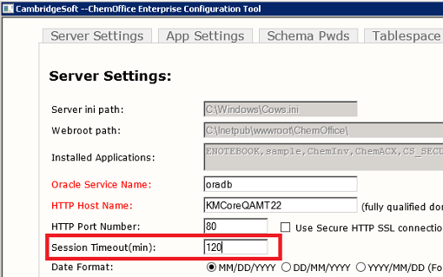

1. Go to **Start > Administrative Tools > Internet Information Services Manager** > Select **Application Pools**.
   1. Right-click **DefaultAppPool,** select **Advanced Properties** and in the **Process Model** section change the **Idle Time-out** to a new value of **120 minutes** or more depending on your needs. Click **OK**.

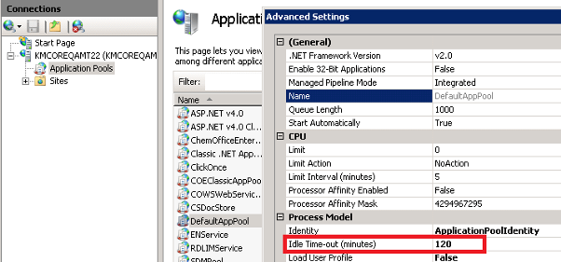

* 1. Right-click **ChemOfficeEnterprise**, select **Advanced Properties**, and in the **Process Model** section change the ‘**Idle Time-out’** to a new value of **120 minutes** or more depending on your needs.Click **OK**.

1. Expand the **Sites** tree > Select ‘**Default Web Site,** and double-click **ASP** under IIS.

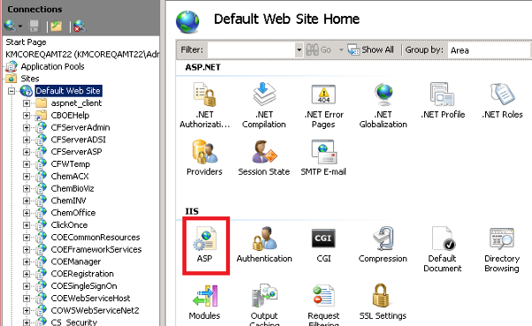

* 1. Expand the **‘Limits Properties’** group and set the ‘**Script Time-out’** property to **02:00:00**.
  2. Expand the ‘Session Properties’ group, and set the ‘**Time-out’** property to **02:00:00**.
  3. Click **Apply**.

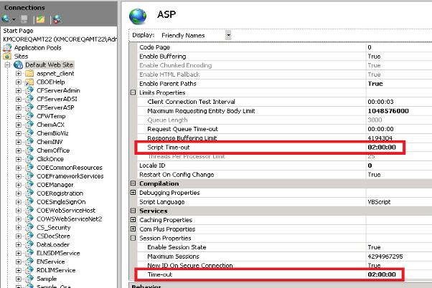

1. Under ‘Default Web Site’ look for the following web sites:

* CFServerAdmin
* CFServerADSI
* CFServerASP
* ChemACX
* ChemINV
* ChemOffice
* Cs_Security
  1. Select the web sites one at a time which is mentioned above, double-click the ‘ASP property’, expand the ‘Limits Properties’ group, and set the ‘**Script Time-out’** property to **02:00:00**.
  2. Expand the ‘*Session Properties’* group, and set the ‘**Time-out’** property to **02:00:00.**
  3. Click **Apply**.

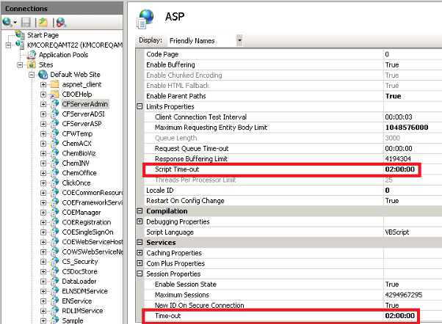

1. Find the file 'Cfserver.ini' in the following locations:

* C:\inetpub\wwwroot\ChemOffice\ChemACX\config
* C:\inetpub\wwwroot\ChemOffice\ChemInv\config
* C:\inetpub\wwwroot\ChemOffice\CS_Security\config

**Note:** You need to **c**reate a backup of the files before proceeding.

* 1. Open each files and search for 'COOKIE_EXPIRES_MINUTES' keyword, and change the value to 120 (For E.g. COOKIE_EXPIRES_MINUTES=120).
  2. Save and close the file.

1. Perform an IISReset.

## Degree and Period Symbols in S Sentences and P Precaution Sentence are not Displaying Properly

**Issue:**

Degree and period symbols in S Sentences & P Precaution Sentences are not displaying properly - (¿)

**Remedy**:

To fix this issue, follow the steps mentioned below:

Connect to the database (CHEMINVDB2/ORACLE) using the sql developer and reinsert the data to the INV_CUSTOM_FIELDS table.

1. DELETE INV_CUSTOM_FIELDS.

Note: If you get any integrity constraint error while deleting the fields, perform the steps below

* Identify the constraint name from the error message
* Identify the table which contains the constraint by using the query "select * from user_constraints where constraint_name = 'constraintname';
* Disable the constant by using the command ALTER TABLE table_name disable constraint 'constraintname';
* DELETE INV_CUSTOM_FIELDS

1. Go to the following location and open **GHS_Hazards.sql** for edit: *C:\inetpub\wwwroot\ChemOffice\ChemInv\config\oracle_install_scripts\Create_blank_ChemInv_DB\sql\Patches\Patch 12.5.0\Data*
2. Copy the whole content starting from “insert into inv_custom_fields values”
3. Paste it in the sql developer and run using Run Script command.
4. Go to the following location and open **Hazards.sql** for edit: *C:\inetpub\wwwroot\ChemOffice\ChemInv\config\oracle_install_scripts\Create_blank_ChemInv_DB\sql\Patches\Patch 12.5.0\Data*
5. Copy the whole content starting from “insert into inv_custom_fields values”
6. Paste it in the sql developer and run using Run Script command.
7. Enable the constraint using the command "ALTER TABLE table_name enable constraint 'constraintname'; "
8. Commit the changes.

If the customer has any customized data in this table then you need to manually update the row which has invalid data. Check the below example for reference.  
Update INV_CUSTOM_FIELDS set custom_field_name = 'S7/47: Keep container tightly closed and at a temperature not exceeding ... °C (to be specified by the manufacturer).' where custom_field_id = 435

## Unable to Browse Inventory Content after Changed Authentication from ORACLE to LDAP or vice versa Once the CBOE System is Setup

In case of Oracle authentication, CBOE authenticates the user directly against the credentials stored in Oracle. In case of LDAP authentication, CBOE uses two level authentication step; One it authenticates with the LDAP using the LDAP credentials and then to start a connectivity with Oracle. It authenticates with Oracle also using a CBOE system generated password (it is by reversing the username and prefixing the reversed username with "7" and suffixing with "11C" e.g. if the username is "abcd" then the generated password is "7dcba11C").

**Oracle to LDAP conversion:**

To resolve this issue, we need to Alter this user in Oracle and setup the password manually to the generate password mentioned above by prefixing and suffixing the additional characters to the reversed username.

e.g. ALTER USER <username> IDENTIFIED BY "7<reversed_username>11C";

So if you need to do this for all the CBOE users in the system we may need to write a database script. Please follow the script given below as an example.

|  |
| --- |
| DECLARE  TYPE CURSOR_TYPE IS REF CURSOR;  dba_username dba_users.username%type;  dba_generate_pass dba_users.password%type;  PEOPLE_RS CURSOR_TYPE;  BEGIN  OPEN PEOPLE_RS FOR  SELECT dba_users.username, '"7' || Upper(reverse(dba_users.username)) || '11C"' FROM dba_users, people  WHERE Upper(dba_users.username) = Upper(people.user_id)  AND Upper(dba_users.profile) = 'CSUSERPROFILE'  AND Upper(dba_users.username) NOT IN  ('CSCARTRIDGE', 'SCOTT', 'BIOSARDB', 'CHEMINVDB2', 'REGDB', 'CHEMACXDB',  'CS_SECURITY', 'CSCUSER', 'CTXSYS', 'D3DATA', 'DBSNMP', 'DMSYS', 'DOCMGR',  'DRUGDEG', 'ORDSYS', 'EXFSYS', 'MDSYS', 'OLAPSYS', 'ORDPLUGINS', 'OUTLN',  'SI_INFORMTN_SCHEMA', 'TSMSYS', 'WMSYS', 'XDB');  LOOP  FETCH PEOPLE_RS INTO dba_username, dba_generate_pass;  EXIT WHEN PEOPLE_RS%NOTFOUND;  execute immediate 'ALTER USER ' || dba_username || ' IDENTIFIED BY ' || dba_generate_pass;  END LOOP;  CLOSE PEOPLE_RS;  END;  / |

***Note****: You may need to skip the CBOE schema users from the update and listed in the "NOT IN clause" of the SQL.*

**LDAP to Oracle conversion:**

In case of changing from LDAP to Oracle authentication, once the CBOE system is setup, we need to do the similar step as mentioned above. Here instead of altering the password of the user to a generated one, we can set it to same as username, so that the user can login to CBOE and change his password to his desired one.

E.g. ALTER USER <username> IDENTIFIED BY "<username>";

For e.g. please follow the script given below as an example.

|  |
| --- |
| DECLARE  TYPE CURSOR_TYPE IS REF CURSOR;  dba_username dba_users.username%type;  dba_generate_pass dba_users.password%type;  PEOPLE_RS CURSOR_TYPE;  BEGIN  OPEN PEOPLE_RS FOR  SELECT dba_users.username, dba_users.username FROM dba_users, people  WHERE Upper(dba_users.username) = Upper(people.user_id)  AND Upper(dba_users.profile) = 'CSUSERPROFILE'  AND Upper(dba_users.username) NOT IN  ('CSCARTRIDGE', 'SCOTT', 'BIOSARDB', 'CHEMINVDB2', 'REGDB', 'CHEMACXDB',  'CS_SECURITY', 'CSCUSER', 'CTXSYS', 'D3DATA', 'DBSNMP', 'DMSYS', 'DOCMGR',  'DRUGDEG', 'ORDSYS', 'EXFSYS', 'MDSYS', 'OLAPSYS', 'ORDPLUGINS', 'OUTLN',  'SI_INFORMTN_SCHEMA', 'TSMSYS', 'WMSYS', 'XDB');  LOOP  FETCH PEOPLE_RS INTO dba_username, dba_generate_pass;  EXIT WHEN PEOPLE_RS%NOTFOUND;  execute immediate 'ALTER USER ' || dba_username || ' IDENTIFIED BY ' || dba_generate_pass;  END LOOP;  CLOSE PEOPLE_RS;  END;  / |

***Note****: You may need to skip the CBOE schema users from the update and listed in the "NOT IN clause" of the SQL.*

## Unknown Error Displays when Trying to Search for a Query While Adding a New Component to a Mixture

**Issue**: The following error appears while trying to search for a query when adding a new component to a mixture.

*"An unknown error has occurred.  
Please go back and try again.  
Failed to load viewstate. The control tree into which viewstate is being loaded must match the control tree that was used to save viewstate during the previous request. For example, when adding controls dynamically, the controls added during a post-back must match the type and position of the controls added during the initial request. "*

**Remedy:**

Follow the workaround steps mentioned below to resolve this issue:

1. Log into the Middle Tier where CBOE application is installed.
2. Go to C:\ProgramData\PerkinElmer\ChemOfficeEnterprise\
3. Open 'COEFrameworkConfig.xml' for edit.
4. Set: "returnPartialHitlist=NO"
5. Save and close the file.
6. Perform IISRESET.

## Errors While Creating New User and Submitting Record to Registration Temp Table in an Oracle 12c Upgraded Machine

**Issue**: The following error appears while creating a new user and submitting record to Registration Temp Table after upgrading Oracle from Oracle 11g to Oracle 12c in an upgraded machine.

ORA-06550: line 1, column 21: PLS-00905: object COEDB.CREATEUSER is invalid ORA-06550: line 1, column 7: PL/SQL: Statement ignored.

**Remedy**:

To fix the issue, connect to database as sys user and execute the following scripts:  
alter system set "_projection_pushdown" = false scope=both

grant select on SYS.USER$ to COEDB;  
*grant insert on sys.user$ to coedb,  
grant update on sys.user$ to coedb.*And compile the schema by using exec dbms_utility.compile_schema('COEDB')

## Invalid Objects in CBOE 19.1 Fresh Database

**Issue**: Invalid objects are shown while executing the script select * from dba_objects where status ='INVALID' on a CBOE 19.1 fresh database.

**Remedy**:

To fix the issue follow the steps mentioned below:

1. Connect to the database system as system/manager.
2. Execute the query shown below for compiling invalid objects.
3. Copy and paste the results one by one and run it.
4. Check all the objects are in valid state.

|  |
| --- |
| select ' alter '||decode(object_type, 'PACKAGE BODY', 'PACKAGE',object_type) ||' '|| owner||'.'||object_name || ' compile ;' Compile_statement_invalid_obj  from dba_objects where status ='INVALID' and object_type <>'SYNONYM' union  select ' alter '||decode(owner, 'PUBLIC', 'PUBLIC ' ||object_type, object_type) ||' '|| object_name || ' compile ;' Compile_statement_invalid_obj  from dba_objects where status ='INVALID' and object_type ='SYNONYM'; |

## Unable to Launch E-Notebook from CBOE Manager after Upgrading CBOE

**Issue**: “HTTP Error404.0- Not found” error appears when clicking on '**Launch ENotebook'** link under **Applications and Utilities** in CBOE Manager web page.

**Remedy**:

To fix the issue, you need to modify the original ENClient URL in **COEFrameworkConfig.xml** file as shown below.

1. Navigate to *C:\ProgramData\PerkinElmer\ChemOfficeEnterprise* and open the **COEFrameworkConfig.xml** file for edit.
2. Navigate to the ENClient URL line as shown

<links>  
<add name="ENClient" display="Launch ENotebook" tip="Launch the E-Notebook application" **url="/ClickOnce/ENotebook.application"** privilege="" linkIconSize="small" linkIconBasePath="Icon_Library/Custom_Collection/PNG" linkIconFileName="Manage_Your_Forms.png" />

1. Update the URL as shown below:

<links>  
<add name="ENClient" display="Launch ENotebook" tip="Launch the E-Notebook application" **url="<Hostname/IP_address>/ClickOnce/ENcontainer.application"** privilege="" linkIconSize="small" linkIconBasePath="Icon_Library/Custom_Collection/PNG" linkIconFileName="Manage_Your_Forms.png" />

1. Save and close the file.

## Loading Compounds from MS Excel 2016 Files Using Inventory Loader and Data Loader is Showing Error

**Issue**: While loading compounds from MS Excel 2016 files using Inventory Loader and Data Loader, the following error displays.

*Error while using Inventory Loader:*

|  |
| --- |
| ---------------------------  InvLoader  ---------------------------  Could not open the specified database.  ---------------------------  OK  --------------------------- |

*Error while using Data Loader:*

|  |
| --- |
| DataLoader  ---------------------------  The ‘MicrosoftACE.OLEDB.12.0’ provider is not registered on the local machine.  --------------------------- |

**Remedy**:

To fix the issue, you need to reinstall "**Microsoft Access Database Engine 2010 Redistributable** **32-bit**".

## Exporting Shopping Cart Details to MS Excel Fails in ChemACX

In ChemACX, if you try to export the shopping cart details into an MS Excel file, you may encounter an error. To avoid getting this error, perform the following steps:

1. Go to **Start > Run** and type “***mmc comexp.msc /32***”. Press **Enter**.
2. Go to **Component Services > Computers > My Computer > DCOM Config**.  
   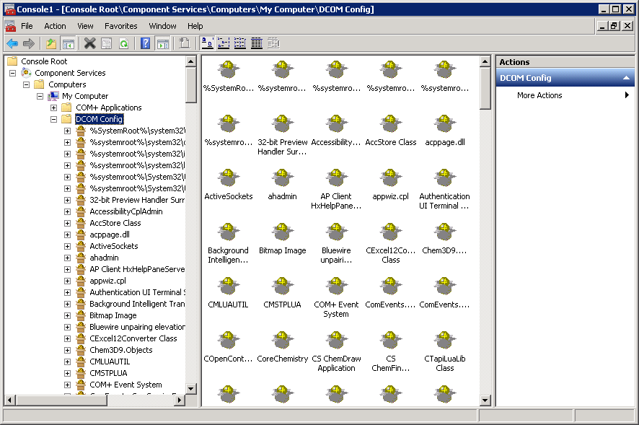
3. Do one of the following:
   1. For MS Office 2016, right-click **Microsoft Excel Application**, and **Microsoft Word 97-2003 Document.**

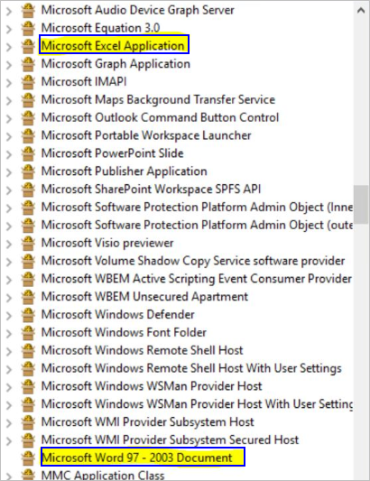

* 1. For the earlier versions of MS Office, right-click the items that start with **Zeroes** (which belong to MS office products).

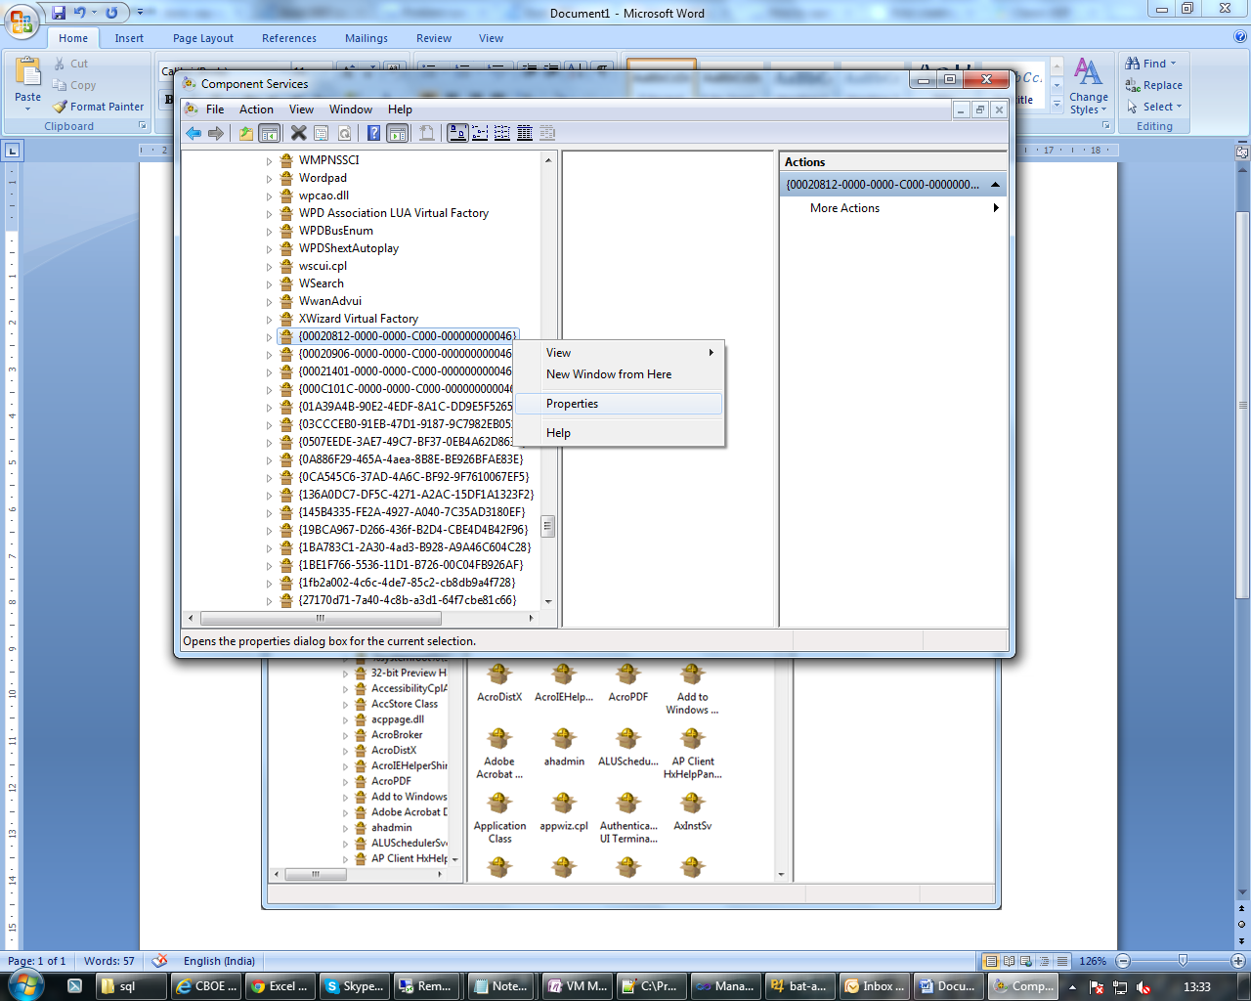

1. From the context menu, select **Properties.**

***Note****: In the* ***General*** *tab, make sure that the Local Path is not empty. If it is empty, the component you have selected in Step 3 is not belongs to MS Office application. You need to select a component with a valid Local Path.*

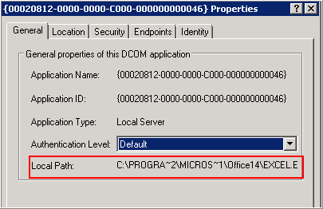

1. Click the **Identity** tab and select ‘**The interactive user’**.

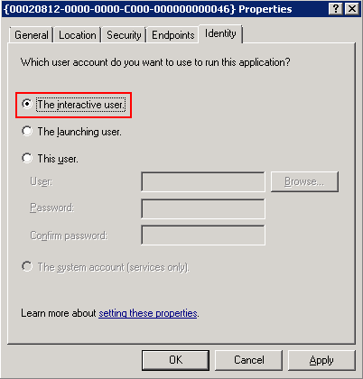

1. Under Security tab, click **Edit** against each group.

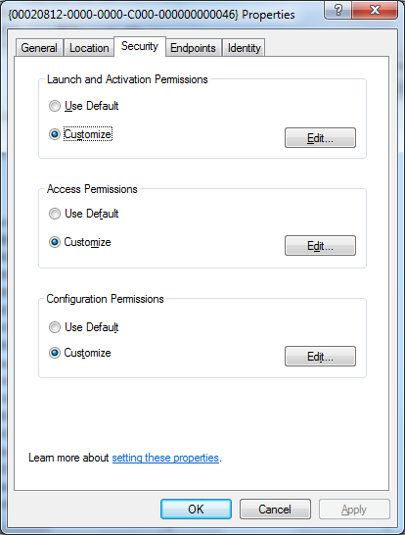

1. Provide full permission to the user group; IUSR, INTERACTIVE and SYSTEM.

***Note****: If the computer is added to a domain, the domain users and groups may also be provided with full permission.*

*You can also provide full permission to the “Everyone” user group, if none of the above configuration seems to be working.*

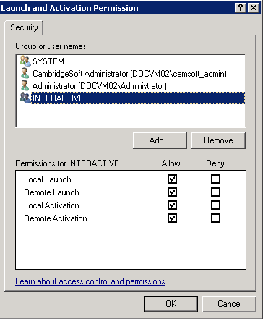

1. Close all dialog boxes and restart IIS.

## Plate Creation from Excel File Fails on an MS Office 2016 Installed Server

An error message appears while creating Plates from an MS Excel 2016 file in Inventory.

To resolve this issue, follow the steps mentioned below.

1. Download and install the MS Office driver components using the link given below. (If you are using 32-bit Office version, download *AccessDatabaseEngine.exe 32 bit*.)  
   <https://www.microsoft.com/en-us/download/details.aspx?id=54920>

***Note****: If you face any issues while installing the driver, follow the steps mentioned in the link below:*[*https://www.itsupportguides.com/knowledge-base/office-2013/solved-how-to-uninstall-office-15-click-to-run-extensibility-component/*](https://www.itsupportguides.com/knowledge-base/office-2013/solved-how-to-uninstall-office-15-click-to-run-extensibility-component/)

1. To configure the driver properly, follow the steps below:
2. Do one of the following:
   * If you have installed the 32-bit driver, go to *C:\Windows\SysWOW64* and select **odbcad32.exe**
3. Right-click and select **Run as administrator**.
4. Select "**Excel Files**" from *User DSN* tab and click **Configure**.
5. Give *Data Source Name* as "**Excel Files**" and select version as **Excel 12.0**.
6. Click **OK**.
7. Go to *System DSN* tab and click the **Add** button.
8. Select "**Microsoft Excel Driver (*.xls, *.xlsx, *.xlsm, *.xlsb)"** and click **Finish**.
9. Select "**Excel Files**" from *System DSN* ab and click **Configure**.
10. Give *Data Source Name* as "**Excel Files**" and select version as **Excel 12.0**.
11. Click **OK**.
12. Click **Apply** and **OK**.
13. Reset IIS.

***Note****: For configuration reference you can check the below link*[*https://docs.microsoft.com/en-us/sql/odbc/admin/managing-data-sources?view=sql-server-2017*](https://docs.microsoft.com/en-us/sql/odbc/admin/managing-data-sources?view=sql-server-2017)

## Searching of Large Records in Registration Takes More Time in Internet Explorer

**Issue**: Searching a record with more than 200 batches is taking more time in Registration. This issue happens when an Internet Explorer browser is used with the URL for CBOE is configured as machine name/IP.

**Solution**:

Internet Explorer in compatibility mode always acts as v4 User agent and in this case it takes more time to display page contents. Since the client and the server are in an intranet environment, the following manual step is required to resolve the issue.

* + Go to: **Internet Explorer settings > Compatibility View settings**, and uncheck the **'Display intranet sites in Compatibility View**' checkbox.

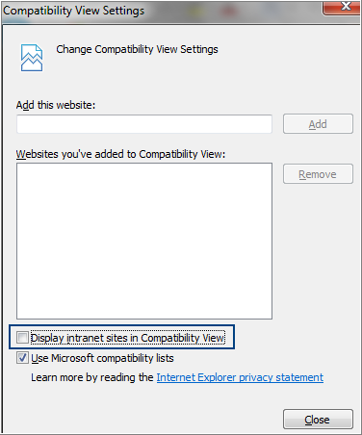

* + Make sure that the CBOE server's name or IP address is not added in the compatibility list '*Websites you've added to the Compatibility View'*.